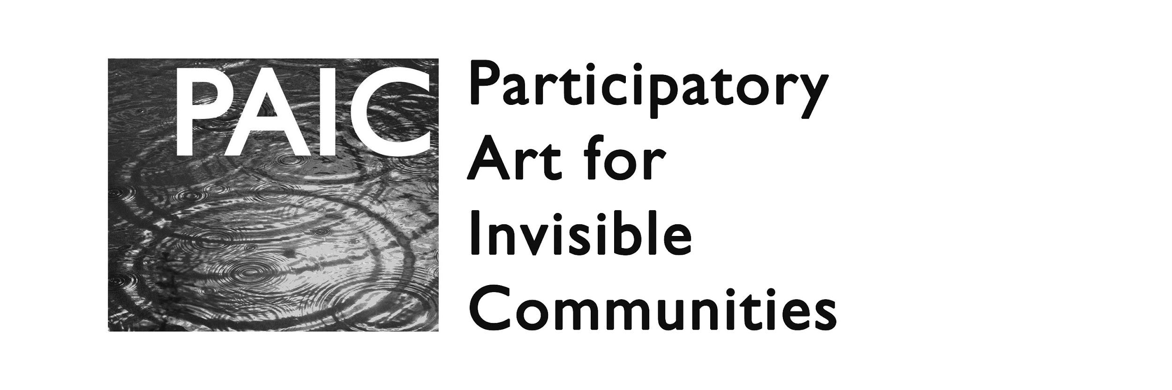
Open call for proposals in the

Participatory Art for Invisible Communities
(PAIC) e-book (TBP October 2018)
The international project PAIC responds to community needs by tailoring artistic methodologies and building capacities of both artists and communities, to establish a platform for exchange and open communication in the field of participatory art.

Submissions are invited from several disciplines, including art practice / theory / history / criticism; sociology, psychology, and other relevant fields. Particularly the interdisciplinary approach is encouraged.

Please send Your abstract to be considered for the e-book* publication, responding to one or more of PAIC topics:
- Tools and Methods in Participatory Art practices
- Communication between artists, mediators and community
- Transformative impact of PA
- Psychological and/or Sociological aspects of PA
- History and/or Criticism of PA
- Strategic and Policy-related aspects of PA
- Different aspects and concepts of Participation

Submissions can include but are not restricted to formats like research articles, personal accounts, creative works, (visual) essays, case studies of projects or initiatives, text-embedded (documentary, experimental etc.) videos etc.

Submission Requirements:
Abstracts of 200-400 words are to be sent by November 15, 2017, to info@paic-project.eu. The PAIC Committee** will select abstracts for publication in the PAIC e-book. Please note that PAIC does not guarantee that any submitted material will be published in the e-book, as all submissions will need to pass the review of the Committee. All submitting authors will be informed about the decision by December 1, 2017. The abstract submission may also contain (reference to) visual or other media material.
Final contributions that shall be composed after a positive selection by the Committee, may have a scope between 400 words (1 page) to 4000 words (10 pages), or an equivalent of visual or other (rich) media material. All submissions must be delivered in Word format (.doc or .docx) and submitted as a single file in an email attachment, to info@paic-project.eu by April 15, 2018 hi-quality picture and/or video materials should be made available via web link.

In all aspects of textual composition, mediography and formatting, please observe the Chicago Manual of Style www.chicagomanualofstyle.org
*About the e-book
Tentative Chapters of the e-book as foreseen:
- Introduction to PA and the PAIC project
- Cultural, Social and Psychological implications of PA
- Policies and Strategies of PA
- PA Histories
- PA Theories
  - Existing theories
  - The PAIC model
- PA Practices
  - Case studies from around Europe and the world
  - Case studies of PAIC workshops
- Selected topics in PA and the Participation concept
- PA in Education
- PA in Research
- The PA “toolbox” (selected tools and methods)
- Lessons learned from PAIC
- Conclusions

The e-book is to be published in October 2018.

It is confirmed to include contributions by highly relevant figures such as Airan Berg, Annie Abrahams, Daniela Brasil, François Matarasso, Jackie Shaw, Judit Font, Kenneth A. Balfelt, Milena Dragićević Šešić, Paul Collard, Randall Packer as well as several other theorists and practitioners of participatory art.
The e-book will be openly accessible and all content will be subject to the Creative Commons ShareAlike 4.0 license ( https://creativecommons.org/licenses/by-sa/4.0/).

**Publication Selection
The submissions will be assessed according to their academic and professional quality as well as topical relevance for the e-book publication.
*The PAIC Committee consists of members:
- Irena Sertić, MA, Omnimedia, head of PAIC project, editor (Croatia)
- Peter Purg, PhD, University of Nova Gorica, scholar and artist (Slovenia)
- Kristina Steinbock, MFA, Soro Kunstmuseum, artist (Denmark)
- Ramon Parramon, PhD, ACVic (Art Center of Vic), curator (Spain)
- Milena Dragićević Šešić, PhD, University of the Arts Belgrade, scholar (Serbia)
- Daniela Brasil, PhD, Technical University Graz, artist and scholar (Austria)

About PAIC project:
Participatory Art for Invisible Communities (PAIC) is a project, supported by the European Commission, that includes professionals and communities from Croatia, Slovenia, Denmark and Spain. It is based on recognizing and answering community needs through artistic methodologies and strives at building capacities of both communities and artists. The aim is to create a platform for creative exchange and open communication through organized workshops, presentations and local forums, inciting creative and open communication. Art and culture are understood as key unifying factors for social justice and sustainability, connecting community members, artists, creative practitioners and cultural operators. More on www.paic-project.eu.

