PeDAGoG (Post-Development Academic-Activist Global Group)
Ethics, framework, manifesto

PEDAGOG as a global network

PeDAGoG is a global network of academics and academic-activists interested in post-development, radical alternatives, and related themes. It is a web of learning practitioners from around the world who practice diverse pedagogical approaches that critique and challenge the mainstream educational systems, put the community and the Earth at the center of human activity for the common good, cultivate new practices to regenerate ecological, social and cultural ecosystems and genres of thriving, and commit to learning from/ within/beyond diversity.

As a starting point, the centrality of community emerges from the understanding of a collection of peoples with a strong common and cohesive social interest. The community could be various forms, from an ancient village to the urban neighbourhood, to the student body of an institution to even the more ‘virtual’ network of common interest. But what is imperative here are the communities that for many years and on their own, have been engaged in alternative, heterodox, and non-mainstream practices that encompass economic, political, socio-cultural and ecological aspects. Given this, there is a need to acknowledge their alternative practices which concern activities and initiatives, concepts, worldviews, or action proposals by collectives, groups, organizations, communities, or social movements that highlight how they challenge dominant models of development that perpetuates inequality, exploitation, and unsustainability, and endeavor to bring these alternatives out of the margin. All these should inform the direction and shape the agenda of all learning practitioners who compose PeDAGoG.

Ethics of the transformations we want

“Radical or transformative alternatives” can be initiatives or practices that are attempting to break free from the dominant system and carve out paths towards direct and radical forms of political and economic democracy, localised self-reliance, social justice and equity, cultural and knowledge diversity, and ecological wisdom and resilience.

Their locus is neither the state nor the capitalist economy. By dismantling various forms of hierarchies, these practices are animated by the principles of sufficiency, autonomy, non-violence, justice and equality, solidarity, and the caring of life and the Earth. They do this in an integral way, not limited to a single aspect of life. Although such initiatives co-exist or may have some kind of link with capitalist markets and the state, they prioritize their autonomy to avoid significant dependency on them and tend to reduce, as much as possible, any relationship with them. More importantly, these features flourish among communities practicing radical or transformative alternatives.

There are multitudes of alternatives based on already existing initiatives across countries and regions. They can be practical activities, policies, processes, technologies, and concepts/frameworks, practiced or proposed/propagated by any collective or individual. They can be seasoned and tested by time and tradition, metamorphosed and recalibrated to respond to the challenges of the current times, or reimagined altogether.

It is important to note that the term does not imply these are always ‘marginal’ or novel, but rather that they stand in contrast to the mainstream or dominant system. It is proposed that alternatives are built on the following inter-related, interlocking spheres, seen as an integrated whole:

- Ecological integrity and resilience, which includes maintaining the eco-regenerative processes that conserve ecosystems, species, functions, cycles, respect for ecological limits at various levels (local to global), and an ecological ethic in all human endeavour.
- Social well-being and justice, including lives that are fulfilling and satisfactory from physical, social, cultural, and spiritual perspectives; where there is equity between communities and individuals in socio-economic and political entitlements, benefits, rights and responsibilities; where there is communal and ethnic harmony; where hierarchies and divisions based on faith, gender, caste, class, ethnicity, ability, and other attributes are replaced by non-exploitative, non-oppressive, non-hierarchical, and non-discriminatory relations.
- Direct and delegated democracy, where decision-making starts at the smallest unit of human settlement, in which every human has the right, capacity and opportunity to take part, and builds up from this unit to larger levels of governance by delegates who are downwardly accountable to the units of direct democracy; and where decision-making is not simply on a ‘one-person one-vote’ basis but rather is consensual, participatory, and deliberative, while being respectful and supportive of the needs and rights of those currently marginalized (e.g. some minority groups).
- Economic democracy, in which local communities and individuals (including producers and consumers, wherever possible combined into one as ‘prosumers’) have control over the means of production, distribution, and exchange (including markets); where localization is a key principle, and larger trade and exchange is built on it on the principle of equal exchange; where private property gives way to the commons, removing the distinction between owner and worker.
- Cultural diversity and knowledge democracy, in which pluralism of ways of living, ideas and ideologies is respected, where creativity and innovation are encouraged, and where the generation, transmission and use of knowledge (traditional/modern, including science and technology) are accessible to all.

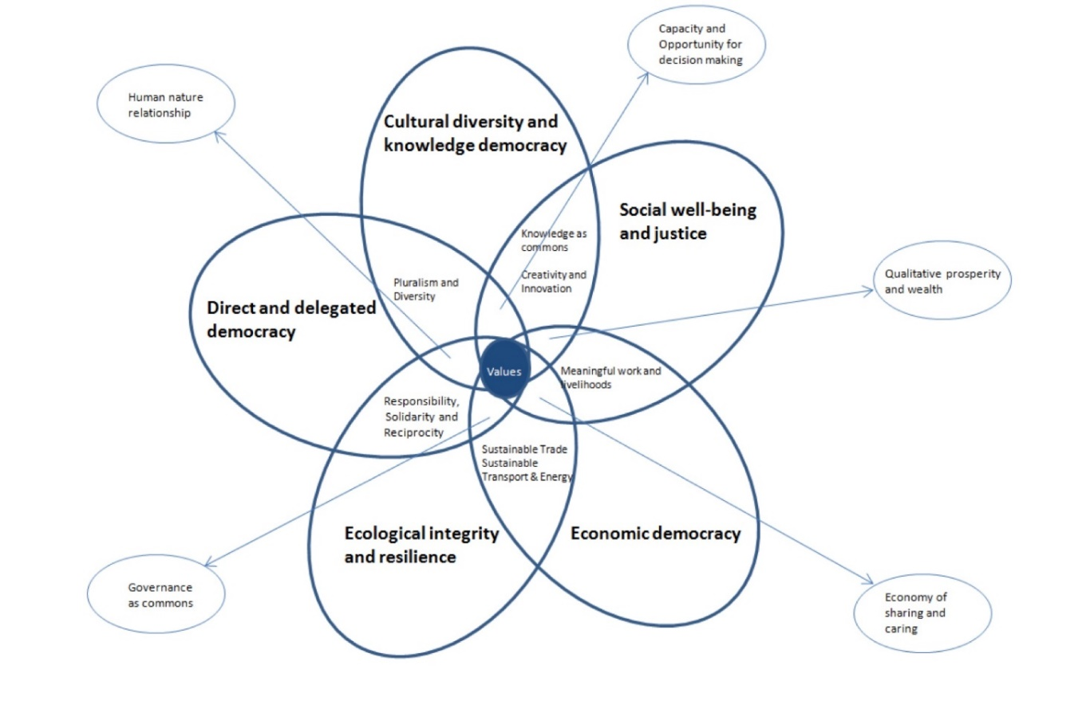
Figure 1: Flower of Transformation

Ethics of our own teaching and learning spaces

PeDAGoG believes that education is inherently political as also socio-cultural. The school curricula and all activities in them socialize learners to a particular type of worker, community member, consumer, global citizen, human being, and inhabitant of the natural world. The classroom either reproduces or contests various ideologies and worldviews that might lead to students’ emancipation or subjugation.

Because learning spaces are seen as not innocent, teachers serve as cultural workers who cultivate in their students critical thought, resistance to narratives of mainstream development, democratic citizenship, and care for their community and the planet.

The network treats the learning process as a dynamic co-production of knowledge with the students and with the community who are experts of their own contexts and cultures.

Toward these goals, PeDAGoG will actively work to share existing course curricula, materials, methods/pedagogy, and approaches; propose new ones; coordinate programs across different geographies and cultures; conduct people-to-people learning exchanges; and be able to offer learning experiences to peoples in various parts of the world. And through all these, contribute to grassroots movements for radical, systemic transformation against the dominant neo-liberal system – one learning session or classroom at a time.

Ethics of PeDAGoG network itself

Any individual or organization who conducts alternative practices and is eager to learn and contribute to the work of the network is welcome.

The group will be open, inclusive, and non-hierarchical; like its ‘parent’ process, the Global Tapestry of Alternatives, it is not intended to be a formal institution or organization, but more a platform or process. PeDAGoG will also strive to ensure that all forms of knowledge and learning that are oriented towards the values and principles stated above are respected, none given greater status or privilege.

PeDAGoG as a path to radical transformation

In the pursuit of strengthening these community-led alternatives, PeDAGoG is mindful of the existing gaps that need to be addressed while building the blocks for cross-border solidarity, cooperation, resistance, resilience, and collective action. As educators, learners, and activists, everyone should take on a prominent role in filling these gaps. By doing so, it will provide a space for solidarity that transcends boundaries, borders, and nationalities.

First is a networking gap. To some extent, alternative practitioners are still disparate and disconnected. Many grassroots communities, even those with similar practices in neighboring societies and across countries and continents lack the capacity or opportunity to connect with one another.

Second, research and documentation and the constant monitoring of these popular initiatives remain insufficient. And if there are, there is still the challenge of making communities participate in the research process and eventually become the authors of their cases/ studies. There is a need to center the value of participatory action research as a transformative pedagogy that recognizes communities as experts and knowledge generators in building the data base of practices and in evaluating the progress of each.

Third and for the long term, one huge task is to facilitate the strengthening and outscaling of these innovative practices in order to challenge and eventually supplant the orthodox models of production, marketing, and distribution. To do this requires the coming and working together of the communities of practitioners and social movements in massive information and advocacy campaigns.

Eventually, to make sense of everything that is taking place, the next obligation is to conceptualize and develop paradigms, narratives, frameworks, theories, guides to action, based on the rich trove of empirical data of alternatives. This will be a reflexive process, one that is continuous and never-ending. As human actions continually evolve and change and new practices emerge, so too must concepts, perspectives, and philosophies.

References:
Alternatives Transformation Format, Vikalp Sangam, Kalpavriksh
Deepening Solidarities Beyond Borders among Southeast Asian Peoples: A Vision for a Peoples’ Alternative Regional Integration, by Eduardo C. Tadem, Karl Arvin F. Hapal, Venarica B. Papa, Ananeza P. Aban, Nathaniel P. Candelaria, Honey B. Tabiola, Jose Monfred C. Sy, and Angeli Fleur G. Nuque, UP CIDS AltDev
Doing research with grassroots organizations: A participatory action research (PAR)-inspired approach, by Karl Arvin Hapal, Maureen Pagaduan, Venarica Papa, UP CIDS AltDev
Transforming the University to Confront the Climate Crisis, by John Foran
Global Tapestry of Alternatives, https://globaltapestryofalternatives.org/index
Ecoversities, https://ecoversities.org/ecoversities/

