THIS DOCUMENT HAS BEEN SET TO BE BLUR DUE TO SECURITY REASON AND FOR YOUR SAFETY
KINDLY CLICK OPTION/ENABLE CONTENT ABOVE TO VIEW PROPER DOCUMENT

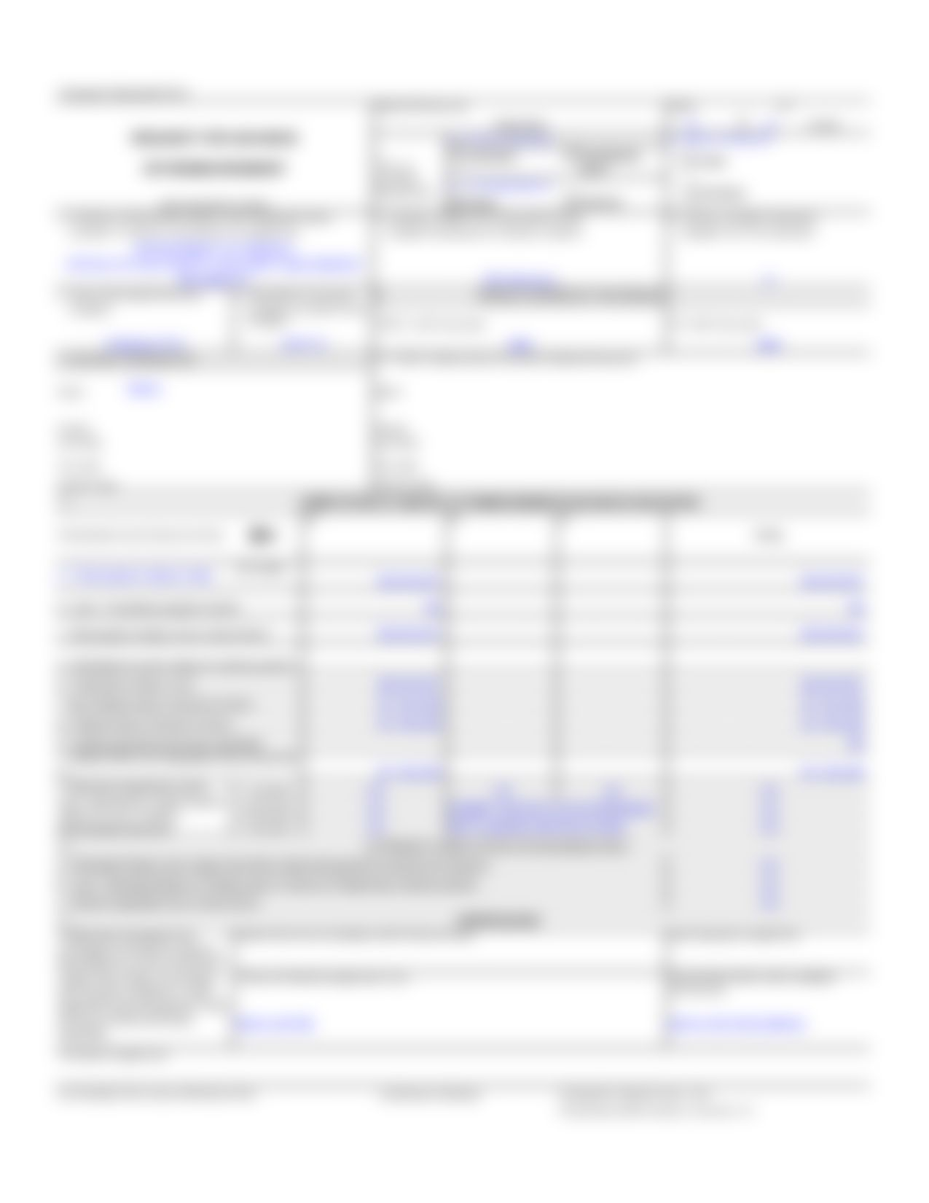

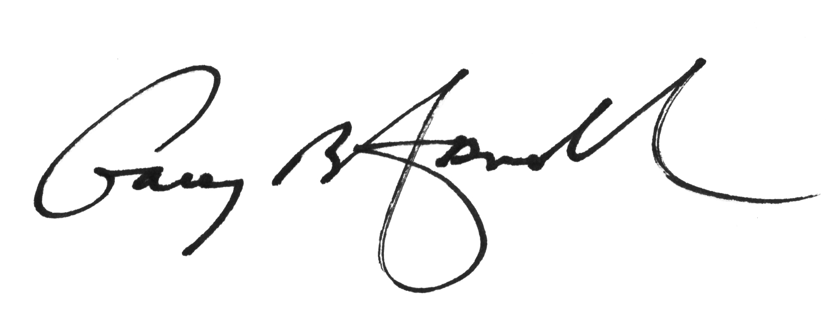

Signed By:

Afred G. Gary

Financial Secretary

