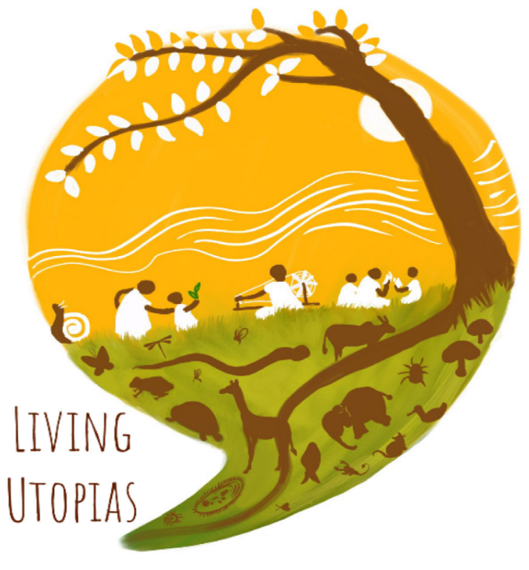
Living Utopias- Sewagram
Feb 10-15, 2020

This is a short 6 day residential course that provides a perspective to understand: a) the urgency in combating the crisis of industrialism in the world today, and b) the various alternatives in different spheres of a civilisation—ecology/ economy/ politics/ socio-cultural/ education and technology.
The course through well outlined examples and case studies, will also showcase few of the new and emerging efforts in India and the world today which are do-able. The course aims to provide a sense of hope and encouragement towards building another world based on the premise of a good society where we ALL not only survive but flourish!
Where? Sewagram, Wardha, Maharashta
When? Feb 10-15, 2020
Who can enrol? It is open to anyone interested in learning, exploring, and engaging with living examples of efforts and networks that provide alternatives to the ideology of industrialism.
Language of Instruction: Primarily Hindi. English translations if needed.
Course faculty: Sujit Sinha and Pallavi Varma Patil, Azim Premji University, Bangalore
Introduction and context of the course:
The word “Development” is associated with the spread of “Industrialism” --- an ideology of ever increasing material growth and consumption through faster and faster exploitation of Nature , using the wonders of large scale Science and Technology, guided by powerful Nation States and Corporations, rising world scale trade , and individualism. Last 30 years of information technology has been able to make almost everyone aspire to climb this endless consumption ladder. This has brought the world to the brink of ecological collapse, depths of socio-economic inequalities and despair, increasingly dysfunctional political institutions, and hugely stressed socio-cultural systems.
In the last few decades, efforts to bring justice, equity, sustainability in the idea of development, can be classified in two broad arenas --- One, what we call , changes within the existing Industrialism paradigm ( such as global efforts to measure development more comprehensively be it the Human Development Index (HDI) , Millennium Development Goals (MDGs), Sustainable Development Goals (SDGs), Green Growth, or the triple bottom line ) And two, what we term as alternatives which are radical challenges to the very premise of Industrialism in all spheres of human civilization ---- economic, ecological, technological, political, and socio-cultural.
In today’s times Industrialism as an ideology continues to grow and spread , the crisis continues to worsen, and the alternatives remain in minority. If the crisis grows faster than solutions, human civilizations will collapse as they have done many times all over the word during last 3000 years. Except this time civilizations are likely to collapse worldwide!
However, there are counter currents of hope across the world, like have always been-- be it the significant old anti-Industrialism ideologies like Gandhi and Tagore’s vision in India , Anarchism in Europe, Ubuntu in Africa, Buen Vivir in Latin America. But today, as the crisis deepens, new ones are emerging such as Degrowth movement in Europe, Radical Ecological Democracy in India, Rights of Nature in Latin America. In today’s times, alternatives are networking with each other and strengthening emerging new ones to counter the collapsing Industrialism. The hope that solutions can and will arise and spread fast to overcome the crisis. We invite you to be part of this exploratory journey with us of efforts striving for a world that is just, equitable, healthy, happy, peaceful , creative, caring , sharing, self- sufficient, self- governing, eco-sustainable, non-exploiting, rural and urban communities.
Learning Objectives
- Understand the key features of INDUSTRIALISM -- its accompanying idea of DEVELOPMENT, its overwhelming ecological crisis today , and its possible collapse
- Discuss some of the major ‘anti-industrialism’ visions and frameworks
- Become familiar with specific emerging alternatives aligned to the above anti-industrialism visions, in India and around the world
- Get linked to some of these alternatives and initiatives
- Grapple with how to adopt and try some of these ideas in their own places of work and living

Please find the day wise schedule attached below.
Detailed day wise agenda
Day 1: Visions and frameworks of alternatives to Industrialism | The CRISIS | Gandhian vision  Tagore’s vision |  | De-Growth | Radical Ecological Democracy RED  Alternate Transformation  Framework | Indigenous visions  Ubuntu  Buen Vivir
Day 2: Alternate imaginations of  Economy | Case study on Detroit: many aspects of solidarity economy including urban farming | Case Study of Mondragon | Solidarity Economy :  Non-market exchanges of goods and services | Case study on Kuthambakam : towards self sufficient gram panchayat | Community Supported Agriculture CSA / Producer Consumer Cooperation | LETS ( local currency) case studies
Day 3: Alternate imaginations of Technology | Reflections on Unit 2 | Appropriate Technology: Kumarappa,  Schumacher, historical perspective and future. | Renewable Energy Community Gobar Gas and solar energy | Water: Rain water harvesting ; open wells | Vernacular Housing | Pedal Power : Various possibilities
Day 4: Alternate imaginations of Democracy | Reflections on Unit 3 | Mendha Lekha  Village participatory consensual democracy | Rights of Nature  Equador, Bolivia , New Zealand | Arvari Sansad  River Parliament  Eco-Regional democracy : | Rojava Movement, Syria  Anarchism in action : | Urban participatory governance :  Innovations from India and world :
Day 5: Alternate imaginations of Society and Culture | Reflections on Unit 4 | The Amish- fairly large community in hundreds of villages who have rejected industrialism | Kibbutz of Israel | Education for the Future | Zapatistas in Mexico : Their Open Learning centres | Film screening
Day 6 : Reflections and way forward | Reflections on Unit 5 | Recap of Frameworks | Some thoughts on strategies | Reflections by participants on how to carry these ideas forward

