Uncertainties in carbon fuel emission maps with high resolution and global extent
Journal suggestions: Global Biogeochemical Cycles, Climate Change, Global Change Biology, …

Martin Köchy¹*, Felix Vogel², Balendra Thiruchittampalam³, Jochen Theloke³, Sanne Palstra⁴, Jos Olivier⁵, Tomohiro Oda^{6a}, Gregg Marland⁷, Ingeborg Levin², Kevin Gurney^{8b}, Annette Freibauer¹, Shobhakar Dhakal⁹, Philippe Ciais¹⁰

1 Johann Heinrich von Thünen-Institut, Bundesallee 50, 38116 Braunschweig, Germany
2 Institut für Umweltphysik, Ruprecht-Karls Universität Heidelberg, Germany
3 Institute for Energy Economics and the Rational Use of Energy, University of Stuttgart, Germany
4 Centre for Isotope Research, University of Groningen, the Netherlands
5 Planbureau voor de leefomgeving, the Netherlands
6 Center for Global Environmental Research, National Institute for Environmental Studies, Japan
7 Environmental Sciences Division, Oak Ridge National Laboratory, U.S.A.
8 Department of Earth and Atmospheric Sciences, Purdue University, U.S.A.
9 Global Carbon Project, National Institute for Environmental Studies, Japan
10 IPSL - LSCE, CEA CNRS UVSQ, Centre d'Études Orme des Merisiers, 91191 Gif sur Yvette, France

* corresponding author:
martin.koechy@vti.bund.de
phone: +49-531-2640
fax: +49-531-2699

ª current address:
Boulder, CO, U.S.A.
^{b} current address:
School of Life Sciences, Arizona State University, PO Box 874501, Tempe, AZ 85287-4501, U.S.A.

Keywords:
fossil fuel emissions, bio fuel emissions, scaling, accuracy, bottom-up and top-down, carbon cycle

Summary [Köchy]
maps

Introduction
The assessment of the continental balance of Greenhouse Gases is indispensible for future efforts to understand and project the human impact on the Earth’s environment. Much of the CO₂ signal observed at atmospheric monitoring locations is due to fossil and bio-based fuel combustion. Estimates of carbon-based fuel emissions are a crucial background signal relied upon in order to interpret monitored CO₂ concentrations, to understand the drivers of carbon-based fuel combustion, and to make use of the flux estimates in advanced atmospheric inverse models. In the first place this requires accounts of the global, annual emissions from all carbon-based fuels. Secondly, it requires that the carbon flux estimates be performed at fine spatial and temporal scales. For instance, for interpreting atmospheric CO₂ concentration gradients between surface stations or for interpreting gradients observed by satellites, emissions must be prescribed as boundary conditions of atmospheric transport models, and thus have to be described at the same spatial and temporal resolution as the numerical simulation of transport. Additionally, national and sub-national aggregated statistics are a tool for validating models and cross-checking. Due to its history, the current global observation network is heterogeneous in space, time, observed variables, and methods. It is funded by a multitude of organizations, institutions, and countries.
Governments throughout the world and international organizations in the Integrated Global Observing Strategy (IGOS) Partnership recognized this heterogeneity and called for a harmonization of methods, data access, definition of measurement and model accuracies, and definition of target granularity of data for inventories, observations, and models. The IGOS carbon report {Ciais et al., 2004, IGOS Carbon Theme Report, #76492} and the recent GEO report on carbon observations {Ciais et al., 2010, #74283} call for estimating fossil fuel and bio-fuel CO₂ sources (fluxes?) at 10 km resolution and a temporal resolution of 3 hours. For detecting not only patterns in space but also significant changes in patterns and validation of models by on-site measurements, it is necessary to characterize emissions at the scales of 1 km × 1 hour, including geo-referenced information on large point sources such as power plants and industrial sites.
In addition to the modeling and scientific understanding, a better estimation with less uncertainty is necessary even for the policy purposes which mostly rely on bottom-up inventory method. Under UNFCCC framework, several nations are currently reporting fossil fuel CO2 and several organizations report annual trends of fossil fuel CO2. A better understanding of uncertainty and a fine grid mapping of fossil CO2 at regional, national, city scale are necessary to substantiate the sources in physical space and to identify the mitigation space.
In this paper we give an overview of some of the currently used methods to quantify CO₂ emissions spatially and temporally. The focus of the review is on the uncertainty involved in the methods and resulting products at the global scale. The account is based on input of participants of a workshop held in 2010 to address uncertainties in these methods. Therefore, the paper does not give a complete picture of all methods and their uncertainties. We also suggest ways to improve international efforts for reducing uncertainty in global fuel emission data products.

Global inventories of fossil fuel emissions
Data on emissions of CO₂ from fossil fuels (coal, oil, and natural gas) are generally estimates calculated from the rate of fuel consumption. At the national level, this frequently means “apparent consumption”, where apparent consumption is (primary fuel production) + (imports) – (exports) – (net changes of fuel in storage) – (fuel loadings for international transport), and all adjusted to recognize that fuels consumed are not necessarily immediately oxidized. Conversion from the conventional units of fuel production and trade to carbon content relies on the strong correlation between heating value and carbon content. The data most commonly available on fuel consumption are at the level of countries and years, although some countries collect energy data at the level of administrative regions and months. Globally these emissions now amount to 9.1 billion metric tons of carbon in the year 2010. Dealing with the global distribution of emissions is facilitated by the fact that 64% of all emissions occur within 10 countries, 77% within 20 countries, and 90% within 50 countries. The overwhelming majority of emissions occur in the northern hemisphere.
Five global databases of fossil fuel emissions exist (Tab. 1) that summarize national and international statistics on fuel production, consumption and trading, cement manufacturing and bio-fuel use. All databases except one (IEA) are available at no cost for download. Annual editions of the complete IEA database are sold as book, CD, or by download but summary tables by country are free for download. Only two of the five databases (EDGAR, CDIAC) also provide spatially disaggregated data. The five databases differ in their selection of data sources, assumptions, filling of gaps, harmonization of source categories, and processing. The EDGAR 4.0 database, for example (Fig. 1), is using the concept of activity data multiplied by emission factors attributed to locations including sub-annual variation. It is using emission factors from the 2006 IPCC guidelines. The database accounts for technological efficiency and end-of-pipe recovery. For spatial disaggregation national statistics of activity are scaled down directly or by proxies to a 0.1° grid. This is complemented by adding emissions from point sources, roads (as a function of population density), residential services (as a function of population density), and grassland and forest fires, plus emissions along international shipping routes and aircraft routes at 1 km altitude bands.

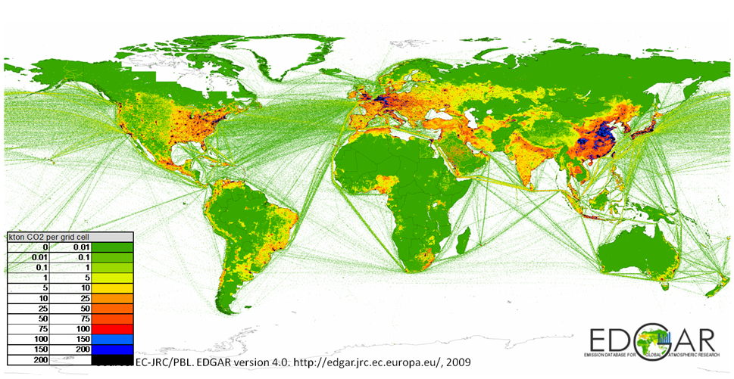
Fig. 1. Spatially disaggregated global emissions of CO₂ based on the EDGAR database.
The global total fossil fuel emission values are typically estimated to have an accuracy of 6 to 10%, depending on whether or not data for the three primary fuels (gas, oil, and coal) are independent of each other {ref?}. Estimates for individual countries can have much larger uncertainty, especially for developing countries (ref), and for countries with a larger relative share of non-fuel use emissions and bunker fuels {ref ? ; Ciais et al., 2010, #74283}. Even negative values for emissions of CO₂ have been reported when, for example, reported exports exceed reported production. Inaccuracy in the databases arises from the uncertainty of activity data which correlates with the size of a country and activity of a sector. Fortunately, more developed countries (with larger emissions) have better national statistics checks. The accuracy of the data depends further on the appropriateness of the proxy used for downscaling, treatment of border cells, changes in the territories of countries, and different behaviour of emission compounds from one source type (e.g. CO and CO₂ from cars). In the development of an emissions database large sources of error can arise from using data outside their range of validity (e.g. to other years) due to temporal variation, switching on or off of point sources, and climate gradients within countries that have effects on the proxies used. A key issue with bottom-up emission inventories is the diversity of data and methodologies used in different studies. This leads to error amplification while aggregating. For e.g., activity data are often based on sales, estimated by levels of activities and factors as proxies, scaled from regional and national information, and model etc. For trans-boundary transport such as treatment to aviation, marine and road transport, those vary from city to city. The CO₂ estimation methodologically differs in terms of factors such as: gases measured, emission sources covered, sector definitions, scopes of the measurement, global warming potential used, and tier methods. These limitations need to be understood.
A comparison across databases (CO₂ Scorecard, http://CO2scorecard.org, accessed 2012-01-25) for the last available year in each database provides an estimate of the accuracy for the processing of the national data. For example, the CO₂ emissions from fossil fuel for Uruguay (2005–2009) have a mean of 6.4 Tg and a relative variability of ±20%. The variability of CO₂ emissions of the U.S.A. (mean 5620 Gg for 2008-2009) is smaller in relative terms (±7%) but three orders of magnitude greater in absolute terms. A comparison between CDIAC and EDGAR inventories found that the largest relative differences in emissions were for some developing countries {ref: Marland et al.}, but the largest absolute differences were for countries with the best data systems. The estimates for the U.S. differed by only 0.9%, but in absolute terms this difference was larger than the total of emissions from 147 of the 195 countries considered.
Transparency and consistency are components of database (un)certainty in the sense of the IPCC guidelines {Todorova et al., 2003, International Emission Inventory Conference, #86968}. The documentations of the EDGAR, CDIAC, and UNFCCC database are extensive and therefore transparent in the sense of the IPCC guidelines. All databases must cope with inconsistencies among the national and international database sources, changes in the reporting procedures of each country, splitting of and, more rarely, merging of countries, and changes in scientific assessments of estimation procedures across years. These changes can cause inconsistencies among different editions of one database that are pointed out in all databases. This inconsistency can be reduced by reprocessing the source data for each year using internally consistent methods as is done for the EDGAR, CDIAC, and UNFCCC databases. We could not determine from publicly available sources whether IEA and EIA reprocess their databases.

Table 1. Inventories of global CO₂ emissions from aggregated national or international statistics.
EDGAR: http://edgar.jrc.ec.europa.eu/index.php, CDIAC: http://cdiac.ornl.gov/trends/emis/meth_reg.html, IEA: http://www.iea.org/CO2highlights, EIA: http://www.eia.doe.gov/emeu/international

 | Methodology | spatial/temporal grain | time frame | accuracy assessment
EC Joint Research Centre (JRC) and Netherlands Environmental Assessment Agency (PBL) “EDGAR” v.4 | activity data multiplied by technology-based emission factors by country or region obtained from international statistics,  uses IPCC 1996 emission categories, spatial distribution by point sources, industrial and population density | 0.1° and per country, 1 yr | 1970–2005, c. biennial updates | expert judgments of accuracy and comparison with other databases for v.2
U.S. Department of Energy–Carbon Dioxide Information Analysis Center (CDIAC) “Annual Fossil-Fuel CO₂ Emissions” | based primarily on UN statistics about fossil-fuel burning, cement manufacturing and gas flaring in oil fields as well as energy production, consumption, and trade data, using the methods of Marland and Rotty {%Marland & Rotty, 1984, Tellus B, #23492}; spatial distribution by population density | 1°, 1 mon/1 yr | 1751-2008 (annual), 1950-2008 (monthly), annual updates | not found
International Energy Agency (IEA), “CO₂ Emissions from Fuel Combustion” | CO₂ emissions from fuel combustion are calculated using IEA and UNFCCC data applying the default methods and emission factors from the Revised 1996 IPCC Guidelines for National Greenhouse Gas Inventories. Reference and sectoral approach. | per country, 1 yr | 1971–2010, annual updates | assessment of sources of internal inconsistencies and differences to other databases
U.S. Energy Information Administration (EIA) “International Energy Statistics, Indicators, CO₂ from fossil fuel”* | based on national and international aggregate statistics; conversion to emissions done by private company, methodology not identified | by country/1 yr | 1980–2009, annual updates | not found
United Nations Framework Convention on Climate Change (UNFCCC) | collection of national reports according to common rules | per country/1 yr | 1990-2009 | in each country report, but not stated in summary reports

Spatial disaggregation of inventories
The two databases (EDGAR and CDIAC) that disaggregate emission data spatially use population density as a proxy for fuel consumption and hence emissions. Population density is also used in projections of future CO₂ emissions. This proxy of fuel consumption itself must be estimated for each cell on a grid although total population counts are available for most countries and usually even for smaller administrative regions. High concentrations of populations represent urban areas with very different emission sources, e.g. industry, than urban areas. This requires that urban and rural regions be treated differently. The distinction and estimates of population density provide their own problems with repercussions on estimates of the spatial pattern of CO₂ emissions.
A recent estimate by the IEA city energy modeling group (World Energy Outlook 2008, IEA) shows that urban areas had contributed 67% and 71% to global primary energy and global energy-related CO₂ emissions respectively. Urban areas constitute only 2.2% of the global land area. Furthermore, almost all future global population growth will come from increases in urban population. In 2005, there were 3.16 billion and 6.5 billion residents in urban locations and the globe, respectively. This is expected to reach 4.9 and 8.2 billion, respectively in 2030, an increase of 1.8 billion urban inhabitants by 2030 and 3.2 billion by 2050 (UN Population Dept, World Urbanization Prospects, available online). The implications for anthropogenic carbon emissions are further exacerbated by the fact that the majority of urban population growth takes place in developing countries where per capita urban energy use is expected to increase dramatically while carbon friendly fuels are expected to penetrate slowly (WEO, 2008 by IEA). Urban areas are projected to contribute 76% of CO₂ emissions by 2030. This amounts to a net increase of 11 Tg C from the 2006 level of 19.8 Tg C. This is 87% of total global CO₂ increase (12.6 Tg C) in the period. 89% of this increase in urban CO₂ emissions in this period will come from urbanization in the non-OECD countries despite having per capita CO₂ emissions of non-OECD countries far less than that of the OECD countries. OCED cities have contributed little over 50% in global cities’ emissions in 2006, which is likely to fall around 33% by the 2030. In a regional context, the studies done for China, U.S.A. and Europe show that the urban areas contribute 85%, 80% and 69% of energy related CO₂ emissions respectively in the 2006. However, this is subject to change depending on the urban definitions. For example, a study has shown that 76% of the direct final energy consumption occurs in “the census urban area” in the U.S. while 59% occurs in “urbanized areas” and 17% in “urban clusters” (Ref).
Other than CO₂, the urban area’s global, regional and national greenhouse gas (GHG) contributions are yet unknown. One study claims urban area’s global methane contribution to be in the range of 7-14% (REF!) but this was a global extrapolation of a research carried out in Southern California taking the same correlation coefficient between methane and CO₂ emissions. However, it is likely that a smaller share of total GHGs are generated within city boundaries than energy related CO₂, as estimated in the IEA study. This is because land use accounts about 10% of global CO₂ emissions (which takes place outside of cities) and the share of urban areas in the global methane, the second most important GHGs, is expected smaller. Again, such consideration is subject to change depending on the system boundary of urban areas. For example, if GHGs are attributed to the final point of energy consumption rather than at the point of production (e.g. the powerplant), the urban contribution would be far greater (Ref).
UN urban population has no common definition and it accept urban as defined as individual countries.. For e.g. In India the minimum population threshold to be classifies as urban settlements as 5,000 while in Nigeria this threshold in 20,000. Sweden, Denmark and Iceland, by contrast, classify settlements of more than 200 inhabitants as “urban” (Ref). Other studies have shown that global urban population of UN, in global aggregated form, is similar to other estimations using a common-standard-definition of urban (formulated based on number of parameters) except for wide gaps in the regional and national figures. The point to be made and to be understood here is, the lower threshold of the urban definition has potentials to swing the global urbanization levels and thus the estimates of the urban energy and urban carbon.
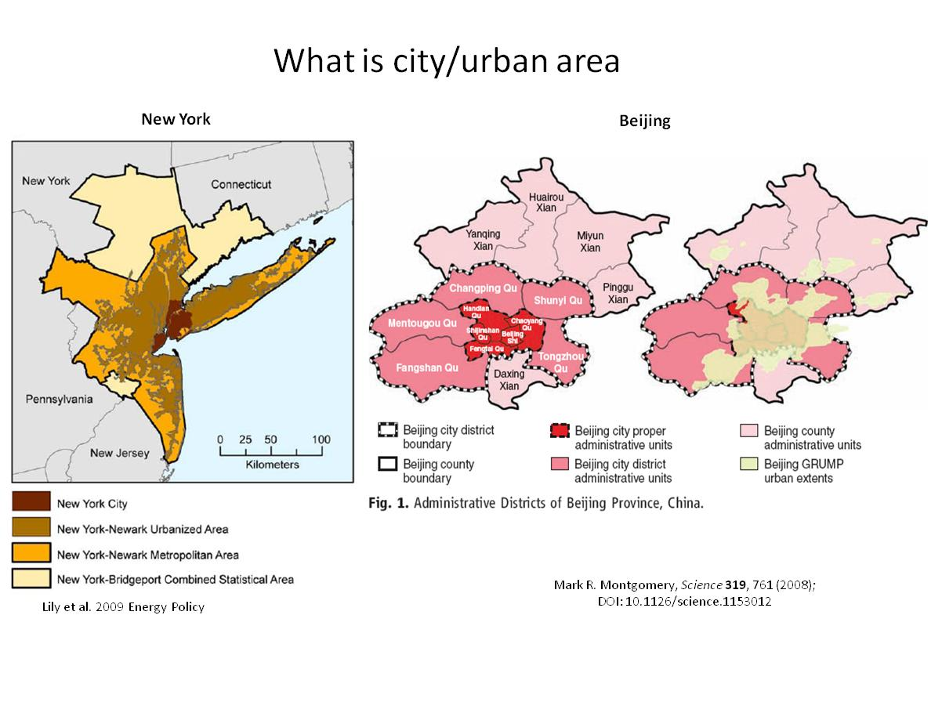
Fig. 2. Illustration of different concepts of ‘urban’.
Such definitional problems regarding what is urban and not urban persist at all levels including specific cities in question. In addition, a majority of the bottom-up studies on urban carbon emissions are available for urban administrative boundaries which are often a small subset of the larger urban agglomeration. This results in a skewed vision of the urban carbon emissions by taking just a part of urban system. For example, in Bangkok City, the industries are on the outer layers of the agglomeration and thus the core city business district’s economic structure, per capita emissions and sectoral contribution is different than an estimate that would have incorporated the whole agglomeration which encompasses five neighboring provinces other than Bangkok Metropolitan City. Another key issue in urban carbon studies is their importance to the aggregated CO₂ emission estimations and analyses at multiple scales. Several aggregated carbon studies over urban administrative boundaries for several cities exists. They are helping us to characterize the urban development pathway classification and their carbon implications; yet few case studies, in terms of city coverage, have been performed. On the one hand, these are important and necessary and the bigger sample size is increasingly needed. On another hand, increasingly they are becoming insufficient in scope. These studies are essentially aggregated analyses, but not spatially explicit. Therefore, these are not aiding much to help us in upscaling the case studies to the level it can feed to the global mapping of CO₂. It requires few key scale-free rules for urban CO₂ emissions for different urban typologies that can cover globally all cities.
Scaling with population density or urban extent alone as proxy is not reliable for estimating CO₂ emissions. Income, lifestyle, energy mix, climate, intra-urban features such as infrastructure affect CO₂ very much. They only provide a black-box snapshot and can’t describe the internal dynamics that are locally needed such as CO₂’s sectoral structures, fuel mix, inter-urban and intra-urban features, key drivers etc. They also use territorial-principle of accounting (allocation of electricity and heat at point of production) whereas city carbon polices tend to account electricity related CO₂ at point of electricity use instead. Top-down mapping and bottom-up (place-based) estimations from urban areas need a better communication and integration. In the context of fine-grid mapping of CO₂ emission from energy use, bottom up studies can serve as very good calibrating agents to improve accuracy of the top-down downscaling of CO₂ at finer resolutions. At the same time, if (a) more urban CO₂ samples were available, especially at agglomeration level (in addition to administrative boundaries) (b) comparable/standardized city carbon inventories could be generated, and (c) few scale free CO₂ rules for different urban typologies could be generated that would greatly complement creating the fine grid global CO₂ data products. For e.g., the rank-size distribution of urban agglomerations and the CO₂ patterns could be useful if more samples were available. The definitional issues (administrative, agglomeration, territorial, consumption) need a careful consideration at all scales. More urban data and better integrated methods are needed and a new thrust for more urban scale data needed in the future to (a) aid generating global fine-grid CO₂ map (b) to calibrate it for accuracy and (c) to possibly use them for meaningful local applications.

Night light and other indicators of fuel consumption
Difficulties in modelling population density and linking it to CO₂ emissions prompted the search for other or additional proxies. Satellite-observed nightlight data have been identified as a useful tool to estimate spatial distribution of CO₂ emission source regions. Digitized nightlight data have been collected by the U.S. Air Force Defense Meteorological Satellite Program’s Operational Linescan System (DMSP-OLS) satellites since 1992 and the data archive has been processed and maintained by the U.S. National Oceanic and Atmosphere Administration (NOAA) National Geophysical Data Center (NGDC) at Boulder CO, USA (http://www.ngdc.noaa.gov/dmsp/downloadV4composites.html, last access: 2011-05-25). Standard products (currently, version 4 products) are available at 30 arc second resolution covering almost entire land masses (180°W-180°E, 65°S-75°N). DMSP-OLS was originally designed to observe clouds illuminated by moon and the instruments have high sensitivity from lights coming from Earth’s surface. The obtained nightlight imagery can be used to pinpoint human settlements {Elvidge et al., 2001, Journal of Photogrammetry and Remote Sensing, #7696} and gas flaring {Elvidge et al., 2007, Final Report to the World Bank, #529}, which are major source regions of CO₂ emissions. In addition, correlation with human population density has been found {\e.g. \Raupach et al., 2010, Energy Policy, #97169}. CO₂ emission maps have been developed using nightlight data at different spatial resolutions {Doll et al., 2000, Ambio, #6206; Ghosh et al., 2010, Energies, #80890; Oda & Maksyutov, 2011, Atmos Chem Phys, #49520; Oda et al., 2010, Proceedings of the Asia Pacific Advanced Network, #84528; Rayner et al., 2010, J Geophys Res, #9191}.
One known problem regarding nightlight proxy for mapping CO₂ emissions is saturated pixels at brighter regions. Due to the high sensitivity to lights, DMSP-OLS causes instrumental saturation over brighter regions such as city cores and gas flares and light intensity level is not properly recorded (truncated) which, without correction, causes an underestimation of emissions. The Fossil Fuel Data Assimilation System (FFDAS) is a data assimilation system based on an extended Kaya identity equation {Rayner et al., 2010, J Geophys Res, #9191}. FFDAS assimilates a standard nightlight product together with other data such as population data and constrains model parameters in the extended Kaya identity equation to produce global fields of CO₂ emissions {Rayner et al., 2010, J Geophys Res, #9191}. In FFDAS, saturated pixels in the standard nightlight products are corrected using a correction equation derived by Raupach et al. {%Raupach et al., 2010, Energy Policy, #97169}. Oda and Maksyutov {%Oda & Maksyutov, 2011, Atmos Chem Phys, #49520} utilized calibrated radiance data for year 1996-1997 {Elvidge et al., 1999, Remote Sensing of Environment, #26986} instead of standard products, which have fewer saturated pixels (currently only newer product for year 2006 is available at http://www.ngdc.noaa.gov/dmsp/download_radcal.html, accessed 2011-05-25), together with the global power plant database CARMA (CARbon Monitoring and Action, http://carma.org/, accessed 2011-05-25), to create global 1km x 1km resolution inventory. In Oda and Maksyutov {%Oda & Maksyutov, 2011, Atmos Chem Phys, #49520}, national emissions were spatially disaggregated in two steps: (1) Emissions from power plants were placed to the exact geographical locations the power plant database CARMA indicates and then (2) emissions from other sources (national total emissions minus emissions from power plants) were distributed according to the intensity of nightlights. The resulting inventory was compared to existing inventories based on the disaggregation of national emissions using the 10 km × 10 km Vulcan inventory of the U.S.A. {\see below, \Gurney et al., 2009, Environmental Science and Technology, #4357} and showed better agreement in spatial distribution compared to existing top-down type inventories {Oda & Maksyutov, 2011, Atmos Chem Phys, #49520}. Oda et al. {%Oda et al., 2010, Proceedings of the Asia Pacific Advanced Network, #84528} developed high-resolution inventory based on the same methodology as Oda and Maksyutov {%Oda & Maksyutov, 2011, Atmos Chem Phys, #49520} presented, but using newer calibrated radiance data product obtained for year 2006.
One of the remaining drawbacks in using nightlight as a proxy might be that the assumed assumption when using nightlight data is a high correlation with population density. At relatively coarser spatial resolution (say 1°× 1°), population data are commonly used as a good proxy {\e.g., \Andres et al., 1996, Glob Biogeochem Cycles, #78976}, thus the assumption usually serves well. The correlation could be worse at finer spatial resolutions as local major sources such as power plants, industries, transportation are not always co-located with population. Including power plant data {Oda et al., 2010, Proceedings of the Asia Pacific Advanced Network, #84528} accounts for a part of the remaining local variation. Further variation caused by differences in source sectors, such as industry, commercial activity, etc. cannot be distinguished by nightlight intensity or population density. The level of correlation with population is not uniform from country to country and from region to region {Raupach et al., 2010, Energy Policy, #97169}. Correlation is very high over developed countries, but less over developing and least developed countries. This is partly because the use of nightlight as proxy usually assumes light (electricity) is a proxy for CO₂ emissions. It is, however, safe to assume that energy efficiency differs among countries around the world. Ghosh et al. {%Ghosh et al., 2010, Energies, #80890} statistically tested some methodologies using Vulcan inventory and population data to overcome drawbacks in the aforementioned studies. They concluded that it is not possible to create independent emission estimates from nightlight data only, but combination use of nightlight and population data might be useful for mapping emissions at finer spatial scales.

Temporal patterns of carbon-based fuel emissions
Knowing the temporal variation of CO₂ emissions over a greater region is important for spatial and temporal aggregation or interpolation of point-based flux measurements. Some temporal patterns are obvious: seasonal due to heating, diurnal with two peaks due to commuter traffic; others are irregular and vary by region and among years: traffic and electricity use due to special events (e.g. Olympics), national holidays or industrial work cycles. Fossil fuel use for heating depends on heating degree days, and a country’s use of hydropower or alternative sources; global averages cancel out consumption in northern and southern hemisphere. While annual statistics of industrial fossil fuel emissions are generally available and most industries collect data on a seasonal or quarterly and often even monthly basis, data are collected only rarely in cycles of less than a month. In contrast, transport models used for comparison of inventory data with observed data work at sub-diurnal resolutions to account, for example, wind patterns. In order to account for fine-grained temporal variation in models, a description of temporal patterns of emissions is required.
Temporal profiles are basically factors which describe the share for a specific period within the year of interest. Such a temporal profile can be distinguished into basic time units like months, days and hours. They should also be the base for a method of temporal disaggregation. Spatially distributed emissions are usually available for several sectors (emission sources) classified according to the IPCC’s Common Reporting Format. The IPCC sector structure has two advantages. First, it is internationally defined so that the data sets of individual countries can be combined seamlessly. Second, a more detailed structure allows applying sector specific information, which improves the accuracy of the results. To derive time profiles for each sector a huge amount of country and sector specific indicator data like load curves for power plants, workings hours for industrial plants, traffic count data for road traffic etc. are necessary. Additionally, for more adequate temporal allocation the knowledge of the influence of the parameters like temperature, daylight savings time, hours of daylight etc. may be applied.
The derivation of the time profiles requires diverse indicator data for each time unit. The availability of meaningful indicators differs by sector and time units (Table 2). The power generation in Europe for instance is a sector with good data availability and can be described using monthly fuel use and hourly load curves. The data availability for such statistic data sets is quite good especially in Europe. In contrast, there are sectors like the commercial, institutional and residential combustion sector where such quantitative data sets are only available for individual countries or only even for regions within a country. As a consequence, assumptions for transfering the correlation to other regions and countries must be developed to derive the time profiles for sectors with poor data availability. Besides the difference between sectors, the data availability differs quite strongly among countries around the globe. Usually, industrialized nations have more accurate and detailed data sources than developing countries.

Table 2. Examples for indicator data to derive temporal profiles
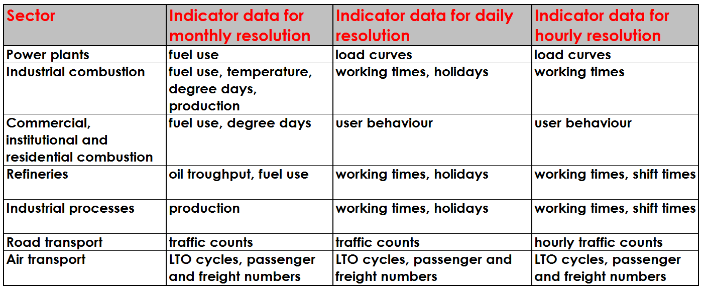

In general, time profiles are developed in a hierarchical manner. Patterns on coarser time scales (e.g. years) constrain variation on finer time scales (e.g. months). This approach works well for average profiles but comparisons of temporal CO₂ emission profiles for specific years and regions must take into account peculiarities of shifting holiday seasons, major public events, weather, and more. Temperature turns out to be an important predictor for emission time profiles.
The influence of the temperature can be derived from correlating the time segment with the corresponding value. For example, mean monthly air temperature is well correlated to monthly coal consumption in power plants in Europe (Fig. 3). After deriving country and fuel specific temperature correlation, CO₂ specific shares of the emissions divided by fuel type can be used to allocate the resulting temperature dependent monthly time profiles for power plants. This can result in inverse relations of fuel consumption among different fuel types (Fig. 4).

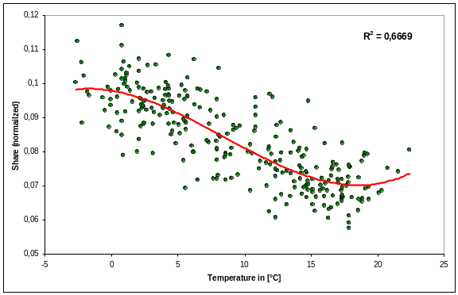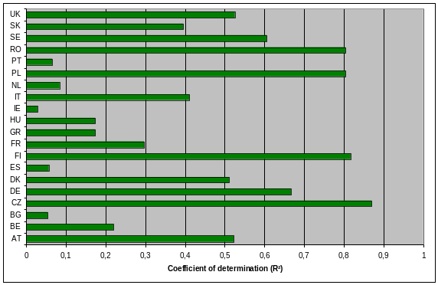
Figure 3: Coefficient of determination of the correlation for coal consumption in power plants and ambient temperature (left: Germany, right: summary for Europe. The correlation is based on consumption data from Eurostat and temperature data {Haylock et al., 2008, J Geophys Res, #29927}.

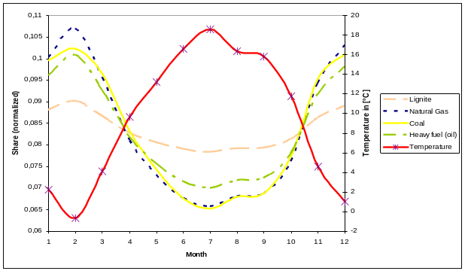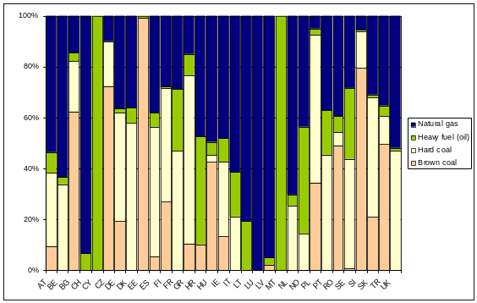
Figure 4: Fuel consumption in power plants according to fuel type for the year 2005 {Thiruchittampalam et al., 2009, International Carbon Dioxide Conference, #87075}. Left: monthly values for Germany, right: summary of the yearly share for Europe based on data derived from the GAINS model {Amann et al., 2011, Environmental Modelling & Software, #56520; Wagner et al., 2008, IIASA Interim Report, #10035}http://gains.iiasa.ac.at).

Time profiles for shorter time units require different statistics. The weekly profile of CO₂ emissions from coal consumption in European countries, for example (Fig. 5), was derived from the Union for the Co-ordination of Transmission of Electricity (UCTE) and the European Network of Transmission System Operators for Electricity (ENTSO-E). Most countries show a decrease in coal consumption on Saturday and Sunday, the end of the working week across Europe. Working days and weekends also differ in their hourly profiles (Fig. 6). The weekly profile would be different for example in countries where Fridays mark the end of the working week and Saturdays and Sundays are regular working days.

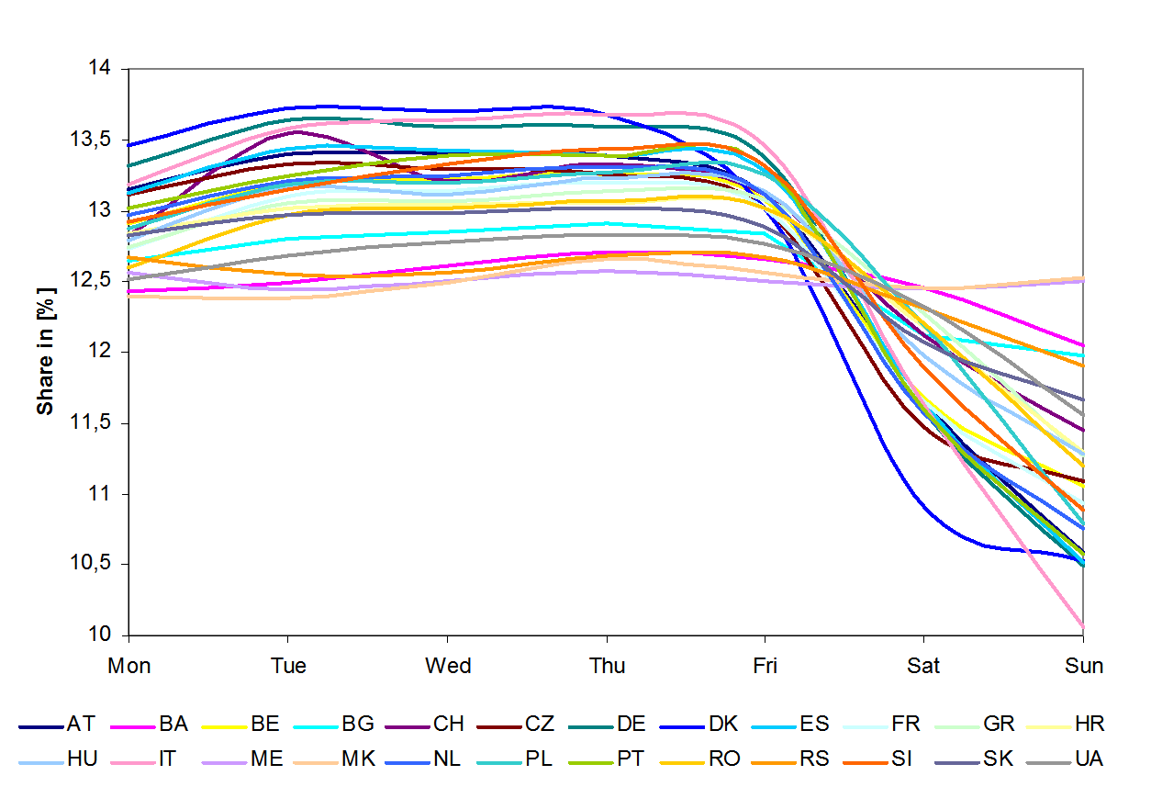
Figure 5. Weekly profiles for European countries derived from UCTE for the year 2006.

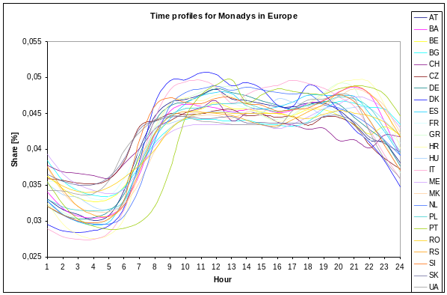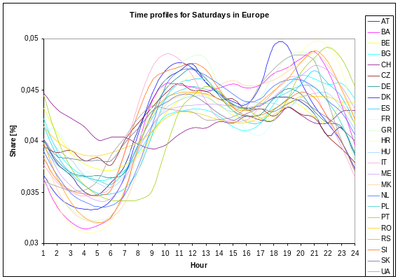
Figure 6. Difference between the hourly time profiles for power plants in different European countries for Mondays and Saturdays {Thiruchittampalam et al., 2009, International Carbon Dioxide Conference, #87075}.

Global temporal patterns of CO₂ emissions are also linked primarily to seasonal climatic patterns. A first set global time profiles for X countries (REF!) was derived using several data sets like the Köppen-Geiger climate classification, average monthly temperature data and also using assumptions for areas with no adequate information to transfer the European time profiles. Additionally, the seasonal shift between northern and southern hemisphere must be considered in the monthly profiles. The seasonal shift between northern and southern hemisphere and its latitudinal amplitude, the different time zones, and different weekend patterns make the simultaneous application of temporal rules at the global scale a challenge (Fig. 7). The weekly profiles seem to be the most irregular because there are countries with working days from Monday to Friday, Sunday to Thursday, and Monday to Saturday etc. This fact and holidays (represented by Sunday) are considered in the different profile types in the set of global country profiles (REF!).
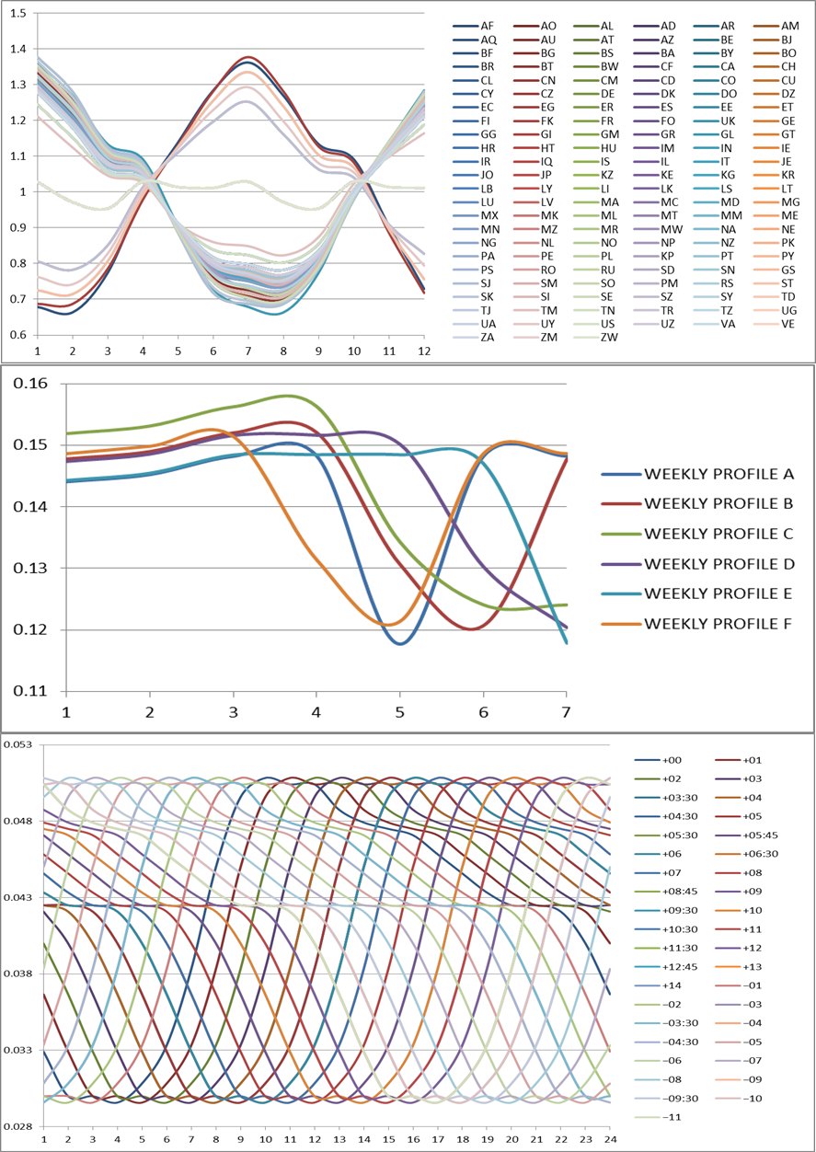
Figure 7. Global time profiles for the energy sector (IPCC reporting code 1A1) for the year 2005 (monthly, weekly and hourly profiles). Hourly profiles were derived from the European average for each time zone for all necessary sectors.

Improvement of emissions data products by in-situ measurements
Spatial and temporal disaggregation of emission estimates to fine-grained grids causes additional uncertainty in the sub-national fluxes compared to the better known annual mean emissions on national scale. This is due to additional parameters and different parameterizations used in the disaggregation procedures. The uncertainty of the different disaggregation procedures could be reduced if in-situ measurements were used to complement bottom-up estimates. For this application measurements in the urban environment are especially interesting as the data are usually easier to interpret given the large CO₂ signals from fossil fuel combustion (FFCO₂). In addition, the focused validation of the CO₂ emission inventories for urban regions is important as these regions hold the major share of anthropogenic CO₂ fluxes of the global primary energy and the global energy related CO₂ emissions (see above).
A great portion of CO₂ levels even in urban areas is biogenic (biomass with a maximum age of approximately 200 years). To account for this increase and its source in models, it is necessary to use a proxy-based approach. Many studies have used the ¹⁴C/C ratio as a proxy because FFCO₂ is free of ¹⁴C and thus leads to a dilution of the atmospheric ¹⁴C/C ratio {Levin, 2003, Geophys Res Let, #81128}. Similarly, ¹⁴C/C ratios can be used to reliably determine the composition of flue gases of point sources when the composition is not known with an accuracy of ±<10% (relatively) {Palstra & Meijer, 2010, Bioresour Technol, #94134}. Apart from a few urban sites that have multi-year records of integrated ¹⁴CO₂ samples {Kuc et al., 2003, Applied Energy, #95433; Levin et al., 2011, Phil Trans A Math Phys Eng Sci, #88283; van der Laan et al., 2010, Tellus B, #33371\, Environment Canada, unpublished\}, most studies are conducted using grab samples on e.g. aircraft {\e.g., \Graven et al., 2009, Tellus B, #32784; Vay et al., 2009, Atmos Chem Phys, #93694} or at greenhouse gas monitoring sites {Conway & Tans, 2009, Trends: A Compendium of Data on Global Change, #68400; Turnbull et al., 2007, J Geophys Res, #95726\, http://gaw.kishou.go.jp/wdcgg\}. Studies focusing on integrated samples have shown that ¹⁴CO₂ is a good proxy in long term-monitoring of atmospheric FFCO₂ levels {Levin & Rödenbeck, 2008, Naturwissenschaften, #69884}. The use of the observation-based data in the fine-grained (in time and space) disaggregation of carbon fuel emissions, however, is limited, due to the relatively fast mixing and transport of emitted CO₂ in the atmosphere and due to the lack of sufficient measurement sites and sampling frequency (poor temporal and spatial resolution).
To gain a thorough understanding of short-term processes, the purely ¹⁴C-based methodology is too expensive and laborious and cannot provide data with fine-grained temporal resolution (e.g. hourly) in line with plant physiological patterns. Carbon monoxide is usually co-emitted in all technical combustion processes. It has already been used as a proxy for FFCO₂ in many studies {Balkwin et al., 1998, Tellus B, #22992; Gamnitzer et al., 2006, J Geophys Res, #34997; Gerbig et al., 2003, J Geophys Res, #87953; Turnbull et al., 2006, Geophys Res Let, #30702}. Unfortunately, the emission ratio of CO/FFCO₂ varies significantly among different emitter groups. This can be accounted for when applying additional constraints i.e. using weekly and diurnal ¹⁴C-calibrated ratios of CO/FFCO₂. The FFCO₂ derived in this manner was shown to agree with the purely ¹⁴C-based FFCO₂ estimates within ±25% for a 7 year long record at an urban European site {Vogel et al., 2010, Tellus B, #45354}.
The FFCO₂ flux on the regional scale can also be assessed by additional proxies that account for the atmospheric mixing. For this purpose especially ²²²Radon is commonly used {Levin, 2003, Geophys Res Let, #81128; van der Laan et al., 2009, #45106; Vogel, 2010, Dissertation, #65126}. Yet, these studies are only able to deliver results with a limited precision of about 30% and for specific meteorological conditions (e.g. during calm nights). Other approaches that utilize atmospheric transport models are evolving rapidly but are currently still limited by the abilities of the atmospheric transport models, which often lack high-resolution input data from, e.g., meteorology {Ahmadov et al., 2009, Biogeosciences, #45150; Geels et al., 2007, Atmos Chem Phys, #24692}.
Estimates of the annual FFCO₂ emission rate of the Netherlands are an example for including information from ¹⁴C, CO, and 222Radon. Measurements at the monitoring station Lutjewad, a 60 m tall tower located in the northern part of the Netherlands, can be used very well to determine annual emission rates of different greenhouse gases for the Netherlands {van der Laan et al., 2009, #45106; van der Laan et al., 2010, Tellus B, #33371} because the most frequent wind direction at the station is Southwest. With this wind direction the air that passes the instruments on the tower has travelled over a major part of the Netherlands and therefore represents an average emission signal of the Netherlands.
To determine the annual FFCO₂ emission rate of the Netherlands, first a quasi-continuous site-specific FFCO₂ signal (‘FFCO₂ excess value’) was calculated based on ¹⁴C measurements of bi-weekly integrated atmospheric CO₂ samples from Lutjewad and background site Jungfraujoch, Switzerland, and based on continuous CO measurements at Lutjewad. Then, temporal subsets of the measurement data were selected when (among some other criteria) no significant vertical mixing has taken place (based on continuous ²²²Rn measurements and the measured wind speed) and when the air masses represent Dutch emissions (analysis of trajectories). For the selected time periods, the surface flux of FFCO₂ was calculated using the continuous ²²²Rn measurements of Lutjewad and the ²²²Rn flux method {Levin, 1984, Dissertation, #78455; Schmidt et al., 1996, Tellus B, #75245; van der Laan et al., 2009, #45106}. The average observation-based estimate of the annual FFCO₂ emission rate of the Netherlands, based on 3 years of observations is 4.7 ± 1.6 Gg km⁻² yr⁻¹. The Dutch inventories reported 4.5 ± 0.2 Gg km⁻² yr⁻¹ for the same period. The applied method seems to work very well for the Netherlands. The inaccuracy is, however, relatively large and could be reduced if ¹⁴C was measured continuously (like CO and ²²²Rn), if the number of measurement sites were increased and the variation in the radon flux was known. More research is also needed to investigate the applicability of the method in other countries with other geographical situations.
FFCO₂ mixing ratio observations could also be used for the inventory-independent validation of temporal disaggregation. Validation of temporal disaggregation is even more important than validation of spatial disaggregation because the time profiles used in different models usually rely on the same proxy data e.g. traffic counts, heating day, electricity consumption statistics. This requires targeted and optimized measurements that allow monitoring the FFCO₂ mixing ratio variations on a diurnal time-scale. To be able to validate diurnal disaggregation coefficients, it is necessary to estimate hourly FFCO₂ observations using proxies like CO {Vogel et al., 2010, Tellus B, #45354}. The monitoring is facilitated when the emissions of different sectors differ significantly for different SNAP levels. On a seasonal time-scale e.g. the variation of SNAP2 is prominent and can be on the order of 10 {IER, 2009, #2624} while other levels are on the order of X. With sector-specific emissions the local influence in a regional model changes drastically from season to season as found in measured local FFCO₂ mixing ratios.
Estimates of emissions of other greenhouse gases (GHG) may also be constrained by observations of FFCO₂ or its proxies. Although FFCO₂ emission maps have a limited accuracy, CO₂ emissions are usually the best known among the relevant anthropogenic GHGs {Marland et al., 2008, Trends: A Compendium of Data on Global Change, #47315; Olivier et al., 1999, Environmental Science & Policy, #17605}, as the related processes causing emissions are generally well known and quantified. This is not the case for methane (CH₄) emissions e.g. from landfills or nitrous oxide (N₂O) emissions e.g. from fertilized fields. To be able to improve our knowledge on non-CO₂ GHG fluxes we can utilize the information gained from comparison of FFCO₂ measurements and inventory-based estimates of the non-CO₂ GHGs in question. As different emission sectors often have well-defined emission ratios for the different trace gases (CO/FFCO₂, CH₄/FFCO₂ and N2O/FFCO₂) it is presumably possible to also assess the contribution of different emission sectors to the overall observed or modeled in-situ signal. This may help to pin down the uncertainty of non-CO₂ GHG fluxes in an inversion approach using our knowledge of fluxes due to carbon fuel burning.
Resolution and sampling density of measurement networks are pivotal for improving the detectability of fossil fuel emissions for the purpose of estimating emissions using atmospheric observations (satellite and in situ) and models. Suppose a fossil fuel emission observing system that had unbiased performance and a precision typical of global inversion models fed by forthcoming satellites, say of 100 g C m⁻² yr⁻¹ (see Chevallier at al. 2006, 2007, 2009). Given that precision and a choice of only looking at the highest emitting pixels (say 60% of the total emissions) due to the preferred positioning of measuring stations in presumed high-intensity emission areas, the signal of these pixels at 20 km is hardly within the precision of the system, whereas it is much better at 2 km (Fig. 8). The signal deterioration will get worse with correlated errors, emissions variability, and biospheric flux 'noise' at coarser resolutions. This is a country-specific result (France, a region where emissions are less skewed than in other populated areas, because large thermic power plants are almost absent) and depends on the threshold one places on the exclusion of small sources like small roads or small towns in order to prioritize verifiable sources having a large share of the total emissions such as cities and large point sources. It shows clearly, however, that the accurate measurement of large emission sources should get highest priority.

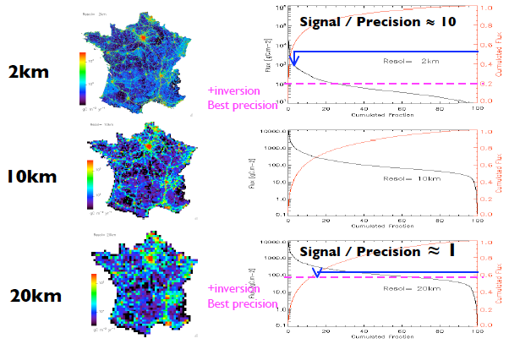
Figure 8. Histograms of emitting pixels (red) and their associated flux (black) for a resolution going from 2 to 20 km.

The role of models
The spatial disaggregation of emission inventories can be quite independent from each other as they use completely different proxy information (nightlights, point source inventories, population density, road maps, etc). They can be checked against maps with geographical information of the respective sources. Nevertheless, it is still possible that all disaggregation models have systematic errors as they may neglect specific emitter groups and sources or may be based on flawed input data. Atmospheric observations, however, are sparse and satellite images have coarse temporal resolution. Here, modeling studies using inversions of atmospheric or remote sensing observations are a valuable tool to better constrain the anthropogenic fluxes.
The accuracy of modelling estimates is still limited by the low accuracy of the applied transport model {Gurney et al., 2002, Nature, #57131; Peylin et al., 2011, Atmospheric Chemistry & Physics, #63913}. A recent development of a high resolution global atmospheric tracer transport model is based on a fusion on Eulerian global tracer transport model and Lagrangian particle dispersion model. High resolution inventories for fossil fuel CO₂ emissions, terrestrial net ecosystem exchange, and ocean exchange were incorporated into the model. The hybrid model allows simulating atmospheric transport at high (1 km × 1 km) resolution at any location on the Earth (REF!).
Even the latest atmospheric transport models, however, are not ready to accept FFCO₂ emissions from high stacks to be vertically distributed. The emissions of those important sources, accounting for 34% of the global total emissions of CO₂ {Oda & Maksyutov, 2011, Atmos Chem Phys, #49520}, are usually parameterized with one height {Pregger & Friedrich, 2009, Environmental Pollution, #30182}. Measurements performed in the vicinity of a large coal power plant {Vogel, 2010, Dissertation, #65126} showed that this causes an overestimation of FFCO₂ levels. This problem must be addressed in order to yield better modeling results. One could either try to provide a 4-D data set for the emissions (time and 3 spatial dimensions) or report the effluent gas temperature to the atmospheric transport models which can then calculate the injection height on-line.
All in all, top-down approaches to disintegration of national statistics are promising, yet continuous measurement data in important source regions are very sparse. Using flask data from the various networks (NOAA-ESRL, CSIRO, NIWA and others) for this purpose does, however, seem less promising. Therefore, there are large efforts within many regions of the world to set up new continuous measurement sites, e.g. in U.S.A (California), Canada, Australia, and other countries. The recent effort in Europe to establish the Integrated Carbon Observation System (ICOS) with more than 40 new tall tower sites distributed over Europe and measuring continuously CO₂, CO, and CH4 in addition to ¹⁴CO₂ on a two-weekly integrated basis with occasional diurnal cycle experiments will significantly improve the situation. For the modeling studies, the improved performance of the transport models with better resolved meteorological fields as well as the availability of sites that provide continuous FFCO₂ measurements could trigger significant progress in our understanding of carbon fluxes.

Complementing methods and sensitivity analysis in fine-scale regional assessments
Two regional studies exemplify how bottom-up and top down-procedures may be combined with modelling studies to derive fine-grained data of CO₂ emissions. Within the CarboEurope project a model of GHG emissions for Europe with high resolution in vertical, horizontal (10 km × 10 km or 0.01°), and temporal (monthly to daily) dimensions was developed. Yearly national totals (obtained from UNFCCC) allocated to sectors were regionalized by proxy resulting in annual values per grid cell. These were temporally disaggregated by using sector specific time profiles (yearly, weekly, daily) on the base of an hourly resolution. The model was subjected to an uncertainty assessment, visual comparisons, and Monte-Carlo analysis in time and space. Applying the model to other continents or sub-continental regions requires knowledge of temporal patterns, especially of large countries like the U.S.A. and China. For this one would need base temporal profiles that reflect dependencies on temperature, national holidays, and other patterns of fossil fuel use.
The Vulcan Project (http://vulcan.project.asu.edu) is a high resolution data product that has quantified fossil fuel CO₂ emissions for the contiguous U.S.A. at spatial scales less than 100 km² and temporal scales as small as hours. This data product, completed for the year 2002, includes detail on combustion technology and forty-eight fuel types through all sectors of the U.S. economy. The Vulcan inventory is built from the decades of local/regional air pollution monitoring and complements these data with census, traffic, and digital road datasets. These datasets are processed by the Vulcan inventory method at both the “native” resolution (geocoded points, county, road, etc) and on a regularized grid to facilitate atmospheric modeling and climate studies (10 km × 10 km). The Vulcan inventory shows close agreement with national-level Department of Energy (DOE) inventories, in spite of the different approach taken by the DOE to quantify U.S. fossil fuel CO₂ emissions.
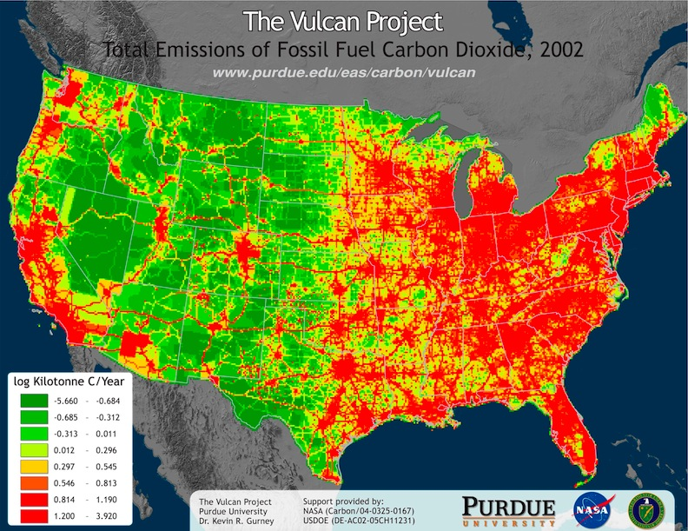
Fig. 9. Estimates of CO₂ emissions from fossil fuels in the contiguous United States by the Vulcan project.
The transformation of the Vulcan incoming datasets to the final space/time resolved CO₂ emissions follows three distinct processes.
1. The first, and simplest, is the incorporation of datasets already representing CO₂ emissions. The only examples of this are emissions associated with airborne aircraft emissions and emissions associated with electricity production facilities which monitor flux via a continuous emissions monitoring (ETS/CEMs) approach. In the latter case, the CO₂ emissions are provided at geolocated positions every hour of the year. The only process required is to assign fuel to the emission amount and this requires cross-linking to DOE fuel use records at each of the electricity production facilities. This does not alter the quantity of CO₂ emitted but enables results reporting by fuel types, useful when comparing to independent estimates at aggregated spatial scales.
2. The second approach is that associated with transforming the CO emissions to CO₂. This is required in handling the point, non-point, and airport incoming datasets. This process can most efficiently be represented for process n (e.g. industrial 10 MMBTU boiler, industrial gasoline reciprocating turbine) and fuel type f (e.g. natural gas or bituminous coal) as:
= / · HC_{f} · · Ox (1)
where is the CO₂ emissions, is the equivalent amount of uncontrolled CO emissions, is the emission factor (emitted quantity per unit fuel consumed) associated with the CO emissions; HC_{f} is the heat content, is the CO₂ emission factor, and Ox is the oxidation factor (100% for natural gas and 99% for coal and oil). The Vulcan documentation (available online) provides complete tabular information on all emission factor and heat content values used in the Vulcan process.
There are two variations to consider in the process described in equation 1. Quantities of emitted CO from a given facility (in the case of point sources) or county (in the case of area sources) may be accompanied by a reported CO emission factor that may additionally require conversion from physical units of fuel (e.g. tonnes, lbs, gallons) to thermal units (e.g. btu, joules). When the CO emission factor is not reported, a default emission factor, supplied in the Vulcan processing, is used.
3. The third approach is used to process the onroad transportation CO₂ emissions. In this case, CO₂ emissions are constructed from estimates of total vehicle miles traveled by all vehicles within a particular class and the CO₂ emission factor for each mile driven by that collection of vehicles. This can be represented as:
= VMTV,X,K · CFV (2)
Where is the CO₂ emissions for vehicle type V, on road type X, in county C, VMT_{V,X,C} is the total vehicle miles traveled in county C, for vehicle class V, and road type X, and CF_{V} is the CO₂ emission factor (mass of CO₂/mile) for vehicle type V (which explicitly designates the fuel – gasoline or diesel). The CO₂ emission factor, in turn can be represented as,
CF_{V} = C · Ox/Eff_{V} (3)
where C is the carbon content of the fuel, Ox is the oxidation factor (99%), and Eff_{V} is the fuel efficiency in miles/gallon for vehicle class V averaged by frequency across vehicle age classes.
In addition to uncertainty associated with the incoming data, there is uncertainty in the application of the key parameters in equations 1-3. Because neither the incoming data nor the parameters in equations 1-3 have measurements or analysis to support the construction of probability density functions, we cannot accomplish a formal estimate of error propagation. Therefore, we take what can be referred to as a “sensitivity” approach. This approach generates a “hi” and “lo” case in an effort to test an upper and lower bound to the central estimate given variations in the data and underlying parameters. We attempt to reflect a 90% confidence interval with this approach but this remains somewhat approximate in definition due to limited clarity in some of the parameter variation. We consider hi and lo bounds for each of the incoming datasets and parameters. This allows us to propagate these boundaries through all the calculations so that a combined hi and lo bound is possible for each county-level estimate. Like the Vulcan estimation itself, this can be categorized by fuel, sector or sub-sector.
Two types of error are applied here. The first is best classified as a measurement error and is utilized for the incoming datastreams. The second is uncertainty due to variation in a parameter. For example, the age distribution of vehicle fleets varies from one county to the next. Hence, if one were to apply a national-mean fleet in all calculations, the error we quantify here is the deviation from the mean represented by a given county. In a broad sense, the first of these two types of uncertainty can be thought of as the standard error on a mean while the second is the standard deviation of a sample (or population). This is appropriate in that the first error type we quantify is applied to data at an individual process, county, or geolocation whereas the second type is applied to parameters that represent mean values presumably derived from samples or populations.
The process used to build the Vulcan emissions data product and the analysis used to assess uncertainty has some potential application to the global domain though the suitability varies and is most notably different between the developed and developing world. For example, there now exists a database on powerplant fossil fuel CO₂ emissions with geolocation and flux estimation. Though this database has some recognized weaknesses, it displays an opportunity to capture a large portion of fossil fuel CO₂ from the bottom-up. Large industrial facilities are similarly tracked but generally only for the industrial world and hence, cannot represent a comprehensive point database of industrial emissions. Transportation offers particular opportunities. Global road atlases exist allowing for better spatial representation of onroad emissions. However, the activity based approach utilized in Vulcan would require data such as vehicle miles traveled, fuel efficiency and fleet information. This level of detail is unlikely in many countries. However, isolation of fuel consumed in onroad transportation combined with the spatial distribution of roads and population could provide a much better spatial representation of emissions. Time structure could be built from a hierarchy of sample traffic count data in different types of cities and levels of development to capture commercial and private transportation patterns. The most challenging sectors to quantify global using an approach similar to Vulcan are the residential and commercial sectors. These dispersed sources are very data limited in many places and are best captured through indirect measures such as nightlight, population or data on building floor space extent. Depending up the region considered, an optimal mixture using an assimilation system such as the FFDAS may offer the best approach to estimating these fluxes. The advantage is that this approach can be calibrated over the US and European domain where high resolution data products exist currently.
Ultimately, operationalization of the Vulcan approach at the global scale requires a combination of the bottom-up techniques used in Vulcan, where data exists, with the type of top-down or proxy approaches taken by other global efforts.

Conclusions
The provision of fossil fuel emission products is ultimately needed at a working resolution of 1 km × 1 hour. This notional requirement stems for the need to prescribe emissions to high-resolution atmospheric transport models for generating concentration fields that could eventually be checked against independent observation. In a first phase during the next 5 years, a coarser spatial resolution of 10 km × 1 hour is suitable with the capacity of global transport models. In many cases, proxy data will be used to estimate the pattern of fossil-fuel use. For example, lack of monthly data on coal consumption in Brazil has led to data on steel production being used to estimate coal consumption, since that industry is responsible for 80% of coal consumption.
Increasing the accuracy of spatially and temporally disaggregated emission products and their validation requires, on the one hand, the prioritization of large emission sources. In statistical approaches this means concentration on the largest emitting countries, annual national totals in general, most strongly contributing sectors, and urban areas. In monitoring approaches this means targeting the concentration and the flow rate of CO₂ in industrial and power plant smokestacks and emissions from fuels used in international commerce (bunker fuels). On the other hand, research should focus on the most unknown sources (aviation, shipping, oil platforms/gas flaring [location known, emissions unknown], biofuels in developing countries, land use change emissions, forestry emissions). Reducing the heterogeneity of definitions, classifications, and methodologies in national data used as proxies or covariables in emission estimates would further decrease the uncertainty of global emission inventories. For accounting for temporal variation in transportation emissions, it is necessary to identify where the fuel is burned as opposed to from where it was last purchased. Identifying the time of day of combustion will also become more important as the temporal grain of emission estimates shrinks. Proxy data, especially wind and other meteorological fields, are required at similar or finer spatial and temporal resolution (1 km, 1 h) as the resultant emissions map but are not routinely available for greater than regional extents. Along the same lines, fully accounting for biogenic emissions requires output from biosphere models on similar space and time scales.
For securing the quality of CO₂ emission products and improvement of models continuous validation by in-situ measurements is necessary. In addition, continuous remote sensing information with relevant resolution is necessary for validation of spatially disaggregated model products and verification of emission reports (and locations) of large point sources. In some areas, the public and non-governmental organizations may be helpful in acquiring missing information. This includes the location of point sources that in official reports may be attributed geographically to the headquarters of companies and the prevalence of regional patterns in fuel consumption.
Global, spatially and temporally disaggregated emission products play a major role in climate change related politics. Most emission databases are freely available for download. Accuracy estimates, including uncertainty analyses and traceability in the basic elements used to construct fossil fuel CO₂ emission maps such as geospatial economic activity information, land cover, light observations from space, emission factors, energy consumption statistics, and version documentation are often not accessible, making the end product intransparent. Nonetheless, demand for access to end-result data is huge but users also ask for easier access to spatial or temporal subsets. Clearly, provision of such diverse services requires appropriate funding.
Describing how emissions are distributed within countries and years encounters many challenges for both the spatial and temporal components. Per capita emissions vary widely both among countries and within countries (a factor of 10 among states in the U.S.A.). The sectoral distribution also differs widely among countries and within countries (for example utilities contribute 49% of emissions from China but only 18% from Sweden). Large point sources can be identified in space but can have large variation over short time spans. Emissions rates from Canada vary by over 30% from summer to winter. Nearly 6% of estimated CO₂ releases globally from hydrocarbon products are from non-fuel uses such as solvents and lubricants - and this value can be much higher in some countries. An estimated 3% of global emissions are from fuels used for international transport and are not accounted for by any country. Consideration of the spatial distribution of emissions needs to acknowledge that emissions vary in essentially a 3-dimensional space as a result of rising plumes from hot gas emissions and emissions from aircraft.
Estimates of emissions from fossil-fuel use, even at the national level, have higher uncertainty than is often appreciated. We can get a feel for the magnitude of uncertainty by comparing estimates by independent methods (there are a number of places where emissions are physically measured at the point of discharge), comparing estimates by different analysts, and comparing estimates by the same analyst over time (i.e. revisions in estimates over time). Pursuing estimates of emissions at fine temporal and spatial scales is a challenging exercise.

Acknowledgements
The sequence of co-authors is in descending alphabetical order. This paper presents the outcome of a workshop of the COCOS project (grant 212196) funded by the Seventh Framework Program of the EU.

References
[put additional references here;
include DOI if possible, that makes formatting for me easier in the end]

Ahmadov R, Gerbig C, Kretschmer R, Körner S, Rödenbeck C, Bousquet P, Ramonet M (2009) Comparing high resolution WRF-VPRM simulations and two global CO₂ transport models with coastal tower measurements of CO₂. Biogeosciences 6: 807–817. doi: 10.5194/bg-6-807-2009
Amann M, Bertok I, Borken-Kleefeld J, Cofala J, Heyes C, Höglund-Isaksson L, Klimont Z, Nguyen B, Posch M, Rafaj P, Sandler R, Schöpp W, Wagner F, Winiwarter W (2011) Cost-effective control of air quality and greenhouse gases in Europe: Modeling and policy applications. Environmental Modelling & Software 26: 1489–1501. doi: 10.1016/j.envsoft.2011.07.012
Andres RJ, Marland G, Fung I, Matthews E (1996) A 1°×1° distribution of carbon dioxide emissions from fossil fuel consumption and cement manufacture, 1950–1990. Glob Biogeochem Cycles 10: 419–429. doi: 10.1029/96GB01523
Balkwin PS, Tans PP, Hurst DF, Zhao C (1998) Measurements of carbon dioxide on very tall towers: results of the NOAA/CMDL program. Tellus B 50: 401–415. doi: 10.1034/j.1600-0889.1998.t01-4-00001.x
Ciais P, Moore B, Steffen W, Hood M, Quegan S, Cihlar J, Raupach M, Tschirley J, Inoue G, Doney S, Heinze C, Sabine C, Hibbard K, Schulze D, Heimann M, Chédin A, Monfray P, Watson A, LeQuéré C, Tans P, Dolman H, Valentini R, Arino O, Townshend J, Seufert G, Field C, Igarashi T, Goodale C, Nobre A, Crisp D, Baldocchi D, Denning S, Rasool I, Cramer W, Francey R, Wickland D (2004) Integrated Global Carbon Observation Theme: A Strategy to Realise a Coordinated System of Integrated Global Carbon Cycle Observations. IGOS Carbon Theme Report 2004,
Ciais P, Dolman AJ, Dargaville R, Barrie L, Bombelli A, Butler J, Canadell P, Moriyama T (2010) GEO Carbon Strategy. GEO Secretariat and FAO, Geneva and Rome.
Conway T, Tans P (2009) Atmospheric carbon dioxide mixing ratios from the NOAA/CMDL Carbon Cycle Cooperative Global Air Sampling Network. Trends: A Compendium of Data on Global Change doi: 10.3334/CDIAC/atg.ndp005
Doll CNH, Muller JP, Elvidge CD (2000) Night-time imagery as a tool for global mapping of socioeconomic parameters and greenhouse gas emissions. Ambio 29: 157–162. doi: 10.1579/0044-7447-29.3.157
Elvidge CD, Baugh KE, Dietz JB, Bland T, Sutton PC, Kroehl HW (1999) Radiance calibration of DMSP-OLS low-light imaging data of human settlements. Remote Sensing of Environment 68: 77–88. doi: 10.1016/S0034-4257(98)00098-4
Elvidge CD, Imhoff ML, Baugh KE, Hobson VR, Nelson I, Safran J, Dietz JB, Tuttle BT (2001) Night-time lights of the world: 1994-1995. Journal of Photogrammetry and Remote Sensing 56: 81–99. doi: 10.1016/S0924-2716(01)00040-5
Elvidge CD, Baugh KE, Pack DW, Milesi C, Erwin EH (2007) A twelve year record of national and global gas flaring volumes estimated using satellite data. Final Report to the World Bank, National Oceanic Atmosphere Administration, National Geophysical Data Center, Boulder, Colorado.
Gamnitzer U, Karstens U, Kromer B, Neubert REM, Meijer HAJ, Schroeder H, Levin I (2006) Carbon monoxide: A quantitative tracer for fossil fuel CO₂? J Geophys Res 111: doi: 10.1029/2005JD006966
Geels C, Gloor M, Ciais P, Bousquet P, Peylin P, Vermeulen AT, Dargaville R, Aalto T, Brandt J, Christensen JH (2007) Comparing atmospheric transport models for future regional inversions over Europe–Part 1: mapping the atmospheric CO₂ signals. Atmos Chem Phys 7: 3479. doi: 10.5194/acp-7-3461-2007
Gerbig C, Lin JC, Wofsy SC, Daube BC, Andrews AE, Stephens BB, Bakwin PS, Grainger CA (2003) Toward constraining regional-scale fluxes of CO₂ with atmospheric observations over a continent: 2. Analysis of COBRA data using a receptor-oriented framework. J Geophys Res 108: D24. doi: 10.1029/2003JD003770
Ghosh T, Elvidge CD, Sutton PC, Baugh KE, Ziskin D, Tuttle BT (2010) Creating a global grid of distributed fossil fuel CO₂ emissions from nighttime satellite imagery. Energies 3: 1895–1913. doi: 10.3390/en3121895
Graven HD, Stephens BB, Guilderson TP, Campos TL, Schimel DS, Campbell JE, Keeling RF (2009) Vertical profiles of biospheric and fossil fuel-derived CO and fossil fuel CO₂:CO ratios from airborne measurements of ∆¹⁴C, CO₂ and CO above Colorado, USA. Tellus B 61: 536–546. doi: 10.1111/teb.2009.61.issue-3
Gurney KR, Law RM, Denning AS, Rayner PJ, Baker D, Bousquet P, Bruhwiler L, Chen YH, Ciais P, Fan S, Fung IY, Gloor M, Heimann M, Higuchi K, John J, Maki T, Maksyutov S, Masarie K, Peylin P, Prather M, Pak BC, Randerson J, Sarmiento J, Taguchi S, Takahashi T, Yuen CW (2002) Towards robust regional estimates of CO₂ sources and sinks using atmospheric transport models. Nature 415: 626–630. doi: 10.1038/415626a
Gurney KR, Mendoza DL, Zhou Y, Fischer ML, Miller CC, Geethakumar S, de lRdC, Stephane (2009) High resolution fossil fuel combustion CO emission fluxes for the United States. Environmental Science and Technology 43: 5535–5541. doi: 10.1021/es900806c
Haylock MR, Hofstra N, Klein T, A. M. G., Klok EJ, Jones PD, New M (2008) A European daily high-resolution gridded data set of surface temperature and precipitation for 1950–2006. J Geophys Res 113: doi: 10.1029/2008JD010201
IER (2009) Spatial and temporal disaggregation of anthropogenic greenhouse gas emissions in Europe: Emission Inventory for Europe 2005., Institut für Energiewirtschaft und Rationelle Energieanwendung, Stuttgart.
Kuc T, Rozanski K, Zimnoch M, Necki JM, Korus A (2003) Anthropogenic emissions of CO₂ and CH₄ in an urban environment. Applied Energy 75: 193–203. doi: 10.1016/S0306-2619(03)00032-1
Levin I (1984) Atmosphärisches CO, Quellen und Senken auf dem europäischen Kontinent, Dissertation, Ruprecht-Karls-Universität Heidelberg, Heidelberg.
Levin I (2003) A novel approach for independent budgeting of fossil fuel CO over Europe by CO observations. Geophys Res Let 30: doi: 10.1029/2003GL018477
Levin I, Rödenbeck C (2008) Can the envisaged reductions of fossil fuel CO₂ emissions be detected by atmospheric observations? Naturwissenschaften 95: 203–208. doi: 10.1007/s00114-007-0313-4
Levin I, Hammer S, Eichelmann E, Vogel FR (2011) Verification of greenhouse gas emission reductions: the prospect of atmospheric monitoring in polluted areas. Phil Trans A Math Phys Eng Sci 369: 1906–1924. doi: 10.1098/rsta.2010.0249
Marland G, Rotty RM (1984) Carbon dioxide emissions from fossil fuels: a procedure for estimation and results for 1950–1982. Tellus B 36: 232–261.
Marland G, Boden T, Andres R (2008) Global, regional, and national fossil-fuel CO₂ emissions. A compendium of data on global change. http://cdiac.ornl.gov/trends/emis/overview.html,
Mays KL, Shepson PB, Stirm BH, Karion A, Sweeney C, Gurney KR (2009) Aircraft-based measurements of the carbon footprint of Indianapolis. Environ Sci Technol 43: 7816–7823. doi: 10.1021/es901326b
Oda T, Maksyutov S (2011) A very high-resolution (1 km×1 km) global fossil fuel CO₂ emission inventory derived using a point source database and satellite observations of nighttime lights. Atmos Chem Phys 11: 543–556. doi: 10.5194/acp-11-543-2011
Oda T, Maksyutov S, Elvidge CD (2010) Disaggregation of national fossil fuel CO₂ emissions using a global power plant database and DMSP nightlight data. Proceedings of the Asia Pacific Advanced Network. 30, pp. 220–229.
Olivier JGJ, Bouwman AF, Berdowski JJM, Veldt C, Bloos JPJ, Visschedijk AJH, Van der Maas CWM, Zandveld PYJ (1999) Sectoral emission inventories of greenhouse gases for 1990 on a per country basis as well as on 1°×1°. Environmental Science & Policy 2: 241–263. doi: 10.1016/S1462-9011(99)00027-1
Palstra SW, Meijer HA (2010) Carbon-14 based determination of the biogenic fraction of industrial CO₂ emissions - application and validation. Bioresour Technol 101: 3702–3710. doi: 10.1016/j.biortech.2009.12.004
Peylin P, Houweling S, Krol MC, Karstens U, Rödenbeck C, Geels C, Vermeulen A, Badawy B, Aulagnier C, Pregger T (2011) Importance of fossil fuel emission uncertainties over Europe for CO₂ modeling: model intercomparison. Atmos Chem Phys 11: 6607–6622. doi: 10.5194/acp-11-6607-2011
Pregger T, Friedrich R (2009) Effective pollutant emission heights for atmospheric transport modelling based on real-world information. Environmental Pollution 157: 552–560. doi: 10.1016/j.envpol.2008.09.027
Raupach MR, Rayner PJ, Paget M (2010) Regional variations in spatial structure of nightlights, population density and fossil-fuel CO₂ emissions. Energy Policy 38: 4756–4764. doi: 10.1016/j.enpol.2009.08.021
Rayner PJ, Raupach MR, Paget M, Peylin P, Koffi E (2010) A new global gridded data set of CO emissions from fossil fuel combustion: Methodology and evaluation. J Geophys Res 115: doi: 10.1029/2009JD013439
Schmidt M, Graul R, Sartorius H, Levin I (1996) Carbon dioxide and methane in continental Europe: a climatology, and ²²²Radon‐based emission estimates. Tellus B 48: 457–473. doi: 10.1034/j.1600-0889.1994.t01-2-00002.x-i1
Thiruchittampalam B, Köble R, Theloke J, Uzbasich M, Kummer U, Geftler T, Wagner S, Friedrich R (2009) Fossil fuel emission modelling: approach and results for Europe. International Carbon Dioxide Conference. 8, Jena.
Todorova S, Lichte R, Olsson A, Breidenich C (2003) National greenhouse gas inventories: application of the principles of transparency, consistency, comparability, completeness and accuracy. 12. International Emission Inventory Conference, 29 April-1 May 2003, San Diego, CA.
Turnbull JC, Miller JB, Lehman SJ, Tans PP, Sparks RJ, Southon J (2006) Comparison of CO, CO, and SF as tracers for recently added fossil fuel CO in the atmosphere and implications for biological CO exchange. Geophys Res Let 33: doi: 10.1029/2005GL024213
Turnbull JC, Lehman SJ, Miller JB, Sparks RJ, Southon JR, Tans PP (2007) A new high precision ¹⁴CO₂ time series for North American continental air. J Geophys Res 112: D11310. doi: 10.1029/2006JD008184
Turnbull J, Rayner P, Miller J, Naegler T, Ciais P, Cozic A (2009) On the use of CO as a tracer for fossil fuel CO : Quantifying uncertainties using an atmospheric transport model. J Geophys Res 114: doi: 10.1029/2009JD012308
van der Laan S, Neubert REM, Meijer HAJ (2009) Methane and nitrous oxide emissions in The Netherlands: ambient measurements support the national inventories. 9: 9369–9379. doi: 10.5194/acp-9-9369-2009
van der Laan S, Karstens U, Neubert REM, Laan-Luijkx IT, Meijer HAJ (2010) Observation-based estimates of fossil fuel-derived CO₂ emissions in the Netherlands using Δ¹⁴C, CO and ²²²Radon. Tellus B 62: 389–402. doi: 10.1111/j.1600-0889.2010.00493.x
Vay SA, Tyler SC, Choi Y, Blake DR, Blake NJ, Sachse GW, Diskin GS, Singh HB (2009) Sources and transport of ¹⁴C in CO₂ within the Mexico City Basin and vicinity. Atmos Chem Phys 9: 4973–4985. doi: 10.5194/acp-9-4973-2009
Vogel FR (2010) ¹⁴CO₂-calibrated carbon monoxide as proxy to estimate the regional fossil fuel CO₂ component at hourly resolution, Dissertation, Ruprecht-Karls-Universität, Heidelberg.
Vogel FR, Hammer S, Steinhof A, Kromer B, Levin I (2010) Implication of weekly and diurnal ¹⁴C calibration on hourly estimates of CO-based fossil fuel CO₂ at a moderately polluted site in southwestern Germany. Tellus B 62: 512–520. doi: 10.1111/j.1600-0889.2010.00477.x
Wagner F, Amann M, Schöpp W (2008) The GAINS Optimization Module as of 1 February 2007. IIASA Interim Report IR-07-004., IIASA, Laxenburg.
Zhou YY, Gurney KR (2011) Spatial relationships of sector-specific fossil fuel CO₂ emissions in the United States. Glob Biogeochem Cycles 25: GB3002. doi: 10.1029/2010GB003822

